Ekaterina I. Alexeeva^{1, 2}, Tatyana M. Dvoryakovskaya^{1, 2}, Kseniya B. Isaeva¹, Tatyana V. Sleptsova¹, Rina V. Denisova¹, Margarita A. Soloshenko¹, Olga L. Lomakina¹, Anna N. Fetisova¹, Mariya G. Rudnickaya¹, Dariya D. Vankova¹, Yuri M. Dyakonov², Alina A. Alshevskaya³, Andrei V. Moskalev³, Anna V. Mamutova¹

¹ National Medical Research Center for Children’s Health, Moscow, Russian Federation
² Sechenov First Moscow State Medical University (Sechenov University), Moscow, Russian Federation
³ Research Center for Biostatistics and Clinical Trials, Novosibirsk, Russian Federation

Early Predictors of the Response to Adalimumab Therapy in Patients With Juvenile Idiopathic Arthritis Without Systemic Manifestations: A Prospective Cohort Study

Corresponding Author:
Ekaterina I. Alexeeva, MD, PhD, Professor, Corresponding Member of the Russian Academy of Sciences, Head of the Rheumatology Department of the National Medical Research Center for Children’s Health, Dean of the Paediatric Faculty of the Sechenov First Moscow State Medical University
Address: 2 Bldg. 1 Lomonosov Ave., Moscow 119991, phone: +7 (499) 134-02-97, e-mail: alekatya@yandex.ru
Article received: Sep 6, 2018; submitted for publication: Oct 30, 2018

Background. Tumour necrosis factor alpha inhibitors are widely used in the treatment of juvenile idiopathic arthritis (JIA). To achieve maximum efficiency of genetically engineered biologic drugs, it is necessary to study predictors of the response to therapy. Objective. Our aim was to identify early predictors of the response to adalimumab therapy in patients with JIA without systemic manifestations. Methods. A prospective cohort study analysed treatment results of patients with JIA without systemic manifestations, who were prescribed adalimumab for the period from August 2008 to August 2014. We studied the relationship between baseline demographic indicators as well as baseline and registered after one month of treatment clinical and laboratory parameters and the best (remission according to the Wallace criteria) response to therapy after one year. Results. In the first year of therapy, 94 (43.9%) of 214 patients achieved remission according to the Wallace criteria. In a multivariate analysis, predictors of achieving remission after one year of adalimumab therapy were the improvement according to the ACR70 criterion after one month of therapy [odds ratio (OR) 3.3; 95% confidence interval (CI) 1.7–6.7], a history of uveitis (OR 1.86; 95% CI 1.03–3.33), a decrease in the number of joints with active arthritis after one month of therapy (OR 1.09; 95% CI 1.02–1.16). During therapy, injection reactions in the form of pain were observed in 36 (16.8%) of 214 patients, infectious diseases of ENT organs — in 85 (39.7%), of the respiratory tract — in 17 (7.9%), and tubinfection — in 13 (6.1%) children. Conclusion. The presence of uveitis, rapid reduction in the number of joints with active arthritis and a high level of response to treatment after one month of adalimumab therapy are predictors for achieving remission during the first year of treatment.
Key words: children, juvenile idiopathic arthritis, therapy, response predictors, genetically engineered biologic drug, adalimumab.
(For citation: Alexeeva Ekaterina I., Dvoryakovskaya Tatyana М., Isaeva Kseniya B., Sleptsova Tatyana V., Denisova Rina V., Soloshenko Margarita А., Lomakina Olga L., Fetisova Anna N., Rudnickaya Mariya G., Vankova Dariya D., Dyakonov Yuri M., Alshevskaya Alina A., Moskalev Andrei V., Mamutova Anna V. Early Predictors of the Response to Adalimumab Therapy in Patients With Juvenile Idiopathic Arthritis Without Systemic Manifestations: A Prospective Cohort Study. Voprosy sovremennoi pediatrii — Current Pediatrics. 2018; 17 (5): 381–388. doi: 10.15690/vsp.v17i5.1954)

RESULTS

Table 1. Characteristics of patients (n =214) with juvenile idiopathic arthritis without systemic manifestations at the start of adalimumab therapy
Parameters | Value
Sex (girls), abs. (%) | 128 (59.8)
Age*, years | 10.3 (7; 13.7)
Duration of JIA history*, years | 4 (2; 7.2)
JIA onset age, years | 4 (2; 7)
Diagnosis by ILAR, abs. (%):
• RF-positive polyarthritis  • RF-negative polyarthritis  • persistent oligoarthritis  • extended oligoarthritis  • enthesitis-related arthritis  • psoriatic arthritis | 3 (1.4)  50 (23.4)  62 (29.0)  30 (14.0)  56 (26.2)  13 (6.1)
Concomitant uveitis, abs. (%) | 105 (49.1)
Aggravation of uveitis*, abs. (%) | 103 (48.1)
Previous therapy**
GEBD-naive patients, abs. (%) | 120 (56.1)
History of two or more GEBD, abs. (%) | 12 (5.6)
History of anti-TNF drugs, abs. (%) | 87 (40.7)
NSAIDs, abs. (%) | 213 (99.5)
Disease-modifying drugs, abs. (%)
• methotrexate  • other drugs:  — azathioprine  — leflunomide  — cyclosporine  — hydroxychloroquine  — sulfasalazine  — cyclosporine  — ≥ 2 drugs simultaneously  — glucocorticosteroids (per os), abs. (%) | 197 (92.1)  149 (69.6)  5 (2.3)  14 (6.5)  8 (3.7)  27 (12.6)  71 (33.2)  94 (43.9)  55 (25.7)  65 (30.4)
Concomitant therapy, abs. (%)
• Methotrexate  • Sulfasalazine  • NSAIDs  • Glucocorticosteroids (per os) | 173 (80.8)  16 (7.5)  136 (63.6)  19 (8.9)
Note. * — before adalimumab therapy; ** — drugs ever taken before adalimumab therapy. JIA — juvenile idiopathic arthritis, GEBD — genetically engineered biologic drugs, NSAIDs — non-steroidal anti-inflammatory drugs.

Table 2. Dynamics of laboratory and clinical parameters of juvenile idiopathic arthritis activity initially and after one month of adalimumab therapy
Parameters | Initial value* | After one month | Difference** | p
ESR, mm/h | 23 (11; 40) | 10 (5; 19) | 11 (-3; 24) | 0.001
CRP, mg/L | 5.9 (1; 18) | 0.8 (0; 4.5) | 3.9 (0.3; 13) | 0.001
Duration of morning stiffness, min | 60 (20; 120) | 0 (0; 15) | 60 (15; 120) | 0.001
Tender joint count, abs. | 4 (2; 10) | 0 (0; 1) | 4 (2; 8) | 0.001
Swollen joint count, abs. | 4 (2; 8) | 2 (0; 4) | 1 (0; 4) | 0.001
Count of joints with limited range of motion, abs. | 4 (2; 11) | 3 (0; 7) | 0 (0; 2) | 0.001
Active joint count, abs. | 4 (2; 10) | 2 (0; 4) | 2 (0; 5) | 0.001
Assessment of disease activity by VAS (doctor), scores | 60.5 (50; 74) | 30 (9; 40) | 30.5 (23; 44) | 0.001
Assessment of disease activity by VAS (parent/patient), scores | 73 (63; 88) | 33 (12; 48) | 37 (29; 50) | 0.001
CHAQ, scores | 1 (0.5; 1.8) | 0.3 (0; 0.8) | 0.6 (0.3; 1) | 0.001
JADAS71, scores | 19.5 (14.9; 28.1) | 8.3 (2.2; 14) | 10.5 (7.2; 15.9) | 0.001
Inactive disease stage according to the Wallace criteria, abs. (%) | 0 (0) | 49 (22.9) | - | 0.001
Note. * — by the time of adalimumab therapy; ** — difference between the initial value of the parameter and its value after one month of therapy. ESR — erythrocyte sedimentation rate, CRP — C-reactive protein, VAS — visual analogue scale.

Table 3. Predictors for achieving remission according to the Wallace criteria in children (n =214) with juvenile idiopathic arthritis without systemic manifestations after 12 months of adalimumab therapy: results of a single-factor logistic regression analysis
Parameters | OR (95% CI) | p
Changes in the count of joints with limited range of motion* | 1.076 (1.037–1.121) | 0.001
Reaching ACR70 after one month of therapy | 3.069 (1.637–5.966) | 0.001
JADAS71 (initially) | 1.046 (1.02–1.074) | 0.001
History of uveitis | 2.326 (1.348–4.055) | 0.003
CHAQ index (initially) | 1.636 (1.165–2.326) | 0.005
Changes in health assessment by VAS (parent/patient)* | 0.977 (0.96–0.992) | 0.005
Reaching the inactive disease stage by Wallace after one month of therapy | 2.722 (1.389–5.578) | 0.005
Reaching ACR30 after one month of therapy | 2.833 (1.363–6.181) | 0.007
Changes in the active joint count* | 1.084 (1.026–1.154) | 0.007
Changes in CRP concentration* | 1.056 (1.017–1.107) | 0.012
ESR changes* | 1.03 (1.007–1.057) | 0.015
Changes in the tender joint count* | 1.051 (1.01–1.098) | 0.018
Changes in the swollen joint count* | 1.055 (0.99–1.132) | 0.109
History of taking non-anti-TNF GEBD | 2.422 (0.829–8.013) | 0.118
Duration of morning stiffness (initially) | 1.002 (0.999–1.004) | 0.142
Age of the disease onset, years | 1.052 (0.981–1.13) | 0.159
Age of the initiation of adalimumab therapy, years | 1.043 (0.979–1.112) | 0.197
Note. * — the OR values (95% CI) were calculated for the magnitude of the decrease in the initial values of the parameter after one month of adalimumab therapy. For quantitative parameters, the OR value (95% CI) was calculated for changes in the parameter values by the corresponding unit. Of all studied parameters (a total of 107), factors with a significance level of p <0.2 are shown. VAS — visual analogue scale, ESR — erythrocyte sedimentation rate, CRP — C-reactive protein, GEBD — genetically engineered biologic drugs.

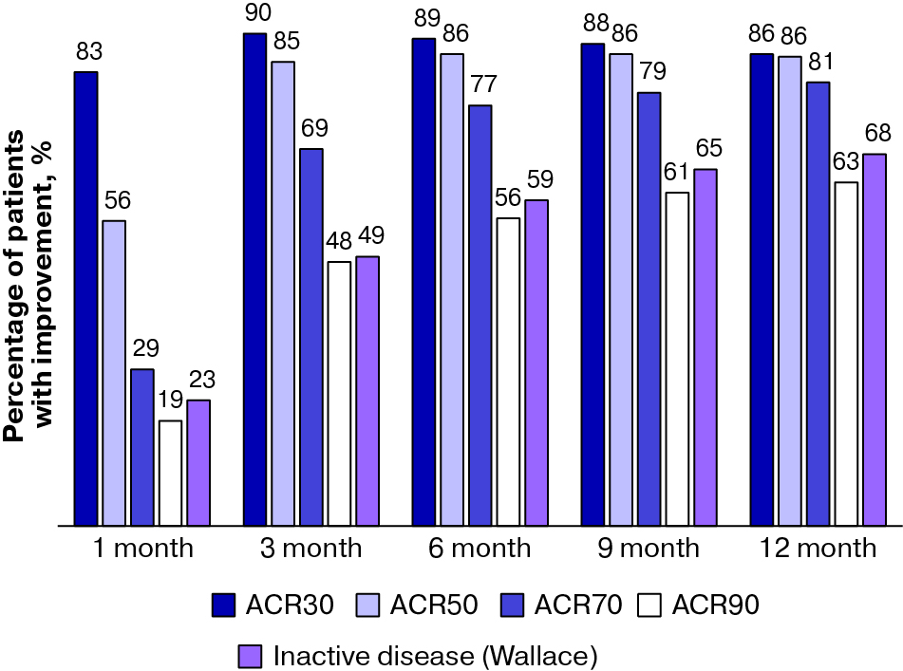

Fig. Dynamics of reaching ACR30/50/70/90 and the inactive disease stage (by Wallace) during 12 months of adalimumab therapy
Note. The proportion of patients who achieved the relevant outcome was calculated according to the intention-to-treat analysis, i.e. for all 214 patients included in the analysis.

Table 4. Predictors for achieving remission according to the Wallace criteria in children (n =214) with juvenile idiopathic arthritis without systemic manifestations after 12 months of adalimumab therapy: results of a multifactor logistic regression analysis
Parameters | OR (95% CI)* | p
Reaching ACR70 after one month of therapy | 3.257 (1.667–6.667) | 0.001
History of uveitis | 1.855 (1.031–3.333) | 0.041
Reducing the active joint count after one month of therapy** | 1.089 (1.02–1.163) | 0.01
History of taking non-anti-TNF GEBD*** | 1.919 (0.592–6.667) | 0.289
Note. * — the OR values (95% CI) were calculated for the difference between the initial values of the parameter and its values after one month of adalimumab therapy. For quantitative parameters, the OR value (95% CI) was calculated for changes in the parameter values by the corresponding unit; ** — a median change on two active joints is taken for changes in the joint count; *** — the parameter is used in the model as when it was deleted, the AIC value increased, which indicates a deterioration in the prognostic characteristics of the model (for details, see «Methods!). Model specifications: AIC =276.4; R2 =16%. GEBD — genetically engineered biologic drugs.

FINANCING SOURCE
Not specified.

CONFLICT OF INTEREST
Ekaterina I. Alexeeva, Tatyana M. Dvoryakovskaya — receiving research funding from Pfizer, Roche, Centocor, Novartis.
Rina V. Denisova — receiving research funding from Roche, Centocor, Novartis.
Tatyana V. Sleptsova — receiving research funding from Centocor, Novartis.
The other contributors confirmed the absence of a reportable conflict of interest.

