**Natalia V. Shakhova1, Elena M. Kamaltynova2, Tatyana S. Kashinskaya1**

1 Altai State Medical University, Barnaul, Russian Federation

2 Siberian State Medical University, Tomsk, Russian Federation

**Diagnosis of Bronchial Asthma in Children 3−6 Years of Age by Using Serum Periostin and Surrogate Markers of Eosinophilic Inflammation (Blood Eosinophils and Total IgE): a Cross-Sectional Study**

**Corresponding author:**

*Shakhova Natalia Viktorovna*, assistant professor of propaedeutic of childhood diseases department in Altai State Medical University, allergist-immunologist

**Address:** 656043, Barnaul, Lenina ave., 40, **phone:** +7 (385) 261-91-82, **е-mail:** [natalia.shakhova@mail.ru](mailto:natalia.shakhova@mail.ru)

**Article recieved:** Feb 12, 2019, **submitted for publication:** Apr 26, 2019.

***Background.*** *It is difficult to diagnose bronchial asthma (BA) in children under the age of 6 due to the limited ability to study respiratory function. Therefore, it is relevant to search for such diagnostic markers of BA that do not require the active participation of a child. The purpose of the study was to assess the diagnostic value of serum periostin levels in comparison with surrogate markers of eosinophilic inflammation (total IgE and blood eosinophils) for the diagnosis of BA in preschool children.* ***Methods****. A cross-sectional**study included children 3–6 years of age with BA and healthy peers. The levels of serum periostin (ELISA), total IgE (chemiluminescent method), blood eosinophils (counted on a hematological analyzer) were determined. To study the diagnostic value of peripheral blood parameters ROC-analysis was used.* ***Results.*** *Children with BA (n = 56) compared with the healthy group (n = 29) showed higher levels of serum periostin (median and quartile) — 5.7 (3.4, 8.0) and 2.7 (1, 7; 3.6) ng / ml (p <0.001), total IgE — 180 (122; 622) and 55 (45; 87) IU / ml (p <0.001), blood eosinophils — 6.1 (3.8 ; 8.0) and 3.6% (2.7; 4.1) (p <0.001). The area under the ROC curve (AUC) for serum periostin was 0.81 (95% CI 0.73–0.89), for total IgE — 0.86 (95% CI 0.77–0.92), for blood eosinophils — 0.77 (95% CI 0.67–0.86). Independent predictors of serum periostin were total IgE and the number of exacerbations of BA over the past 12 months > 2 (R2= 0.527).* ***Conclusion****. The level of serum periostin in preschool children with BA is higher than in their healthy peers. The diagnostic value of serum periostin in BA is in the range from moderate to good and is comparable to that for the levels of blood eosinophils and total IgE.*

***Key words****: serum periostin, bronchial asthma, diagnosis, biomarker, children, preschool age, eosinophils, total IgE, specific IgE.*

*(****For citation****:* Shakhova Natalia V., Kamaltynova Elena M., Kashinskaya Tatyana S. Diagnosis of Bronchial Asthma in Children 3−6 Years of Age by Using Serum Periostin and Surrogate Markers of Eosinophilic Inflammation (Blood Eosinophils and Total IgE): a Cross-Sectional Study. *Voprosy sovremennoi pediatrii — Current Pediatrics*. 2019; 18 (2): 109–117. doi: 10.15690/vsp.v18i2.2013)

**RESULTS**

**Table 1.** Characteristic of patients with asthma (*n* = 56)

|  |  |
| --- | --- |
| **Indicators** | **Value** |
| Allergic rhinitis, abs. (%) | 27 (48) |
| BA severity, abs. (%)   * mild* * moderate * severe | 23 (41)  31 (55)  2 (3) |
| BA control**, abs. (%)   * controlled * uncontrolled | 38 (67)  18 (32) |
| Sensitization to airborne allergens, abs. (%)   * *D. pteronyssinus* * cat dandruff * dog dandruff * birch pollen * timothy grass pollen * artemisia pollen | 33 (58)  21 (37)  20 (35)  8 (14)  20 (35)  4 (7)  10 (17) |
| Therapy, abs. (%)   * iGCS * LTRA * iGKS/LABA * IGKS+LTRA * iGKS/LABA+LTRA | 15 (26)  10 (17)  8 (14)  10 (17)  2 (3) |
| Exacerbations of BA during past 12 months > 2, abs. (%) | 19 (33) |

*Note.* * ― children with intermittent or persistent disease; ** ― estimated with use of TRAC questioner. BA ― bronchial asthma, iGCS ― inhalant glucocorticosteroids, LTRA ― leukotriene receptor antagonist, LABA― long-acting beta-agonist, iGKS/LABA― combination drug.

**Table 2.** Level of serum periostin, total IgE and blood eosinophil count in patients with asthma and in healthy children

|  |  |  |  |
| --- | --- | --- | --- |
| **Indicators** | **Children with BA**  **(*n* = 56)** | **Healthy children**  **(*n* = 29)** | ***р*** |
| Serum periostin, ng/ml | 5,7 (3,4; 8,0) | 2,7 (1,7; 3,6) | 0,001 |
| Total IgE, ME/ml | 180 (122; 622) | 55 (45; 87) | 0,001 |
| Blood eosinophils, cells/mkl | 500 (292; 600) | 200 (210; 400) | 0,001 |
| Blood eosinophils, % | 6,1 (3,8; 8,0) | 3,6 (2,7; 4,1) | 0,001 |

*Note.* The comparison was performed due to Van-der-Waerden test. BA ― bronchial asthma.

**Table 3.** Predictors of serum periostin level in children with asthma (*n* = 56) according to the data of multifactorial linear regression analysis.

|  |  |  |  |
| --- | --- | --- | --- |
| **Indicators** | ***β* factor** | **Standard error** | ***р*** |
| Age | 0,200 | 0,329 | 0,547 |
| Male sex | -0,725 | 0,799 | 0,370 |
| Total IgE | **0,005** | **0,001** | **0,001** |
| Absolute eosinophil count | -2,891 | 2,164 | 0,190 |
| Relative eosinophil count | 0,201 | 0,263 | 0,450 |
| Sensitization to airborne allergens1 | -0,851 | 2,025 | 0,677 |
| Sensitization to *D. pteronyssinus* | -0,232 | 1,074 | 0,830 |
| Sensitization to epidermal allergens2 | 0,935 | 1,416 | 0,513 |
| Sensitization to pollen allergens3 | -1,434 | 0,994 | 0,158 |
| BA symptoms control4 | 0,778 | 0,214 | 0,526 |
| Exacerbations of BA during past 12 months > 2 | **2,542** | **0,743** | **0,001** |
| iGKS therapy | 0,452 | 0,882 | 0,611 |
| LTRA therapy | 0,455 | 1,031 | 0,661 |
| iGKS/LABA therapy | 2,707 | 1,571 | 0,093 |
| iGKS+LTRA therapy | -0,555 | 1,039 | 0,596 |

*Note.* 1 ― identification of specific IgE to at least one out of six airborne allergens; 2 ― cat and dog dandruff; 3 ― birch, timothy grass, artemisia pollens; 4 ― BA symptoms control was estimated with use of TRAC questioner. iGCS ― inhalant glucocorticosteroids, LTRA ― leukotriene receptor antagonist, LABA― long-acting beta-agonist, iGKS/LABA― combination drug. Coefficient of multiple determination (R2) for the model considering all variables is equal to 0,630 (adjusted R2 = 0,503), considering only unrelated predictors of serum periostin level (*p* < 0,05) ― 0,527 (adjusted R2 = 0,509).

**Fig.** Diagnostic value of serum periostin, total IgE and blood eosinophil count: ROC-curve analysis results

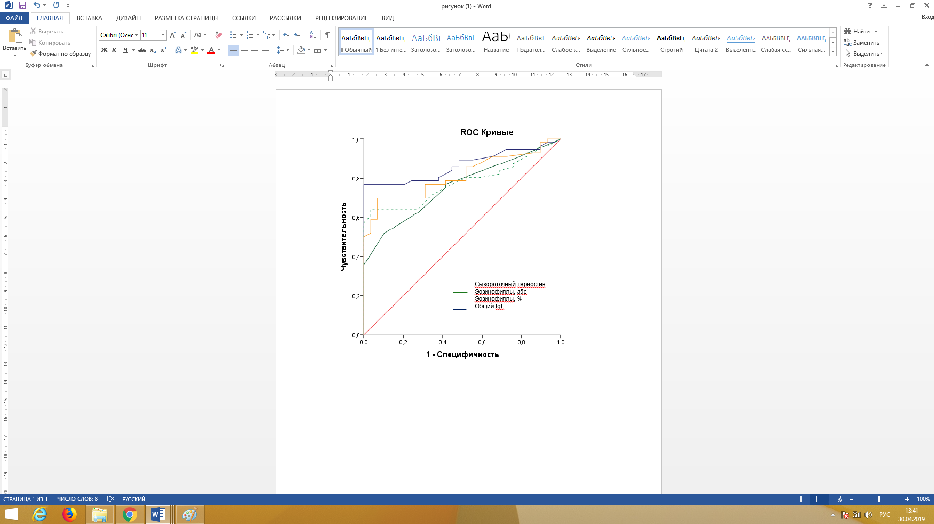

Specificity

Sensibility

Serum periostin

Eosinophils, abs

Eosinophils, %

Total IgE

*Note.* Diagonal line (AUC = 0,5) shows the absence of diagnostic value.

**FINANCING SOURCE**

The study was funded with a grant from the Rector of the Altai State Medical University (Order № 88-ПК dated February 12, 2018).

**CONFLICT OF INTERESTS**

Not declared.