**Valentina A. Aksenova1, 2, Nadezda I. Klevno1, 2, Alexey V. Kazakov1, 2, Dmitry A. Kudlay2, 5, Tatyana A. Sevostyanova3, 4, Elena K. Dementyeva1**

1 National Medical Research Center of Phthisiopulmonology and Infectious Diseases, Moscow, Russian Federation

2 Sechenov First Moscow State Medical University (Sechenov University), Moscow, Russian Federation

3 Moscow City Scientific-Practical Center for Tuberculosis Control, Moscow, Russian Federation

4 Pirogov Russian National Research Medical University, Moscow, Russian Federation

5 JSC «Generium», Moscow, Russian Federation

**Preventive Tuberculosis Services Reduces the Risk of Local Forms of Tuberculosis Development in Children on Immunosuppressive Therapy: Retrospective Cohort Study**

**Corresponding author:**

*Aksenova Valentina A.*, MD, PhD, professor, the Head of pediatric department of National Medical Research Center of Phthisiopulmonology and Infectious Diseases

**Address**: 127473, Moscow, Dostoevsky Str., 4/2, **phone**: +7 (495) 681-92-36, **e-mail**: [v.a.aksenova@mail.ru](mailto:v.a.aksenova@mail.ru)

**Article received**: Aug 08, 2020, **accepted for publication**: Oct 23, 2020

***Background.*** *Long-term immunosuppressive therapy in children (including genetically engineered biologic drugs, GEBD) is associated with a high risk of local tuberculosis (TB) development.* ***Objective****. The aim of the study was to examine efficacy of tuberculosis services in children with high risk of developing tuberculosis associated with immunosuppressive therapy.* ***Methods.*** *The study included children at the age from 0 to 17 years on immunosuppressive therapy due to autoimmune disease and who were referred to phthisiatrician consultation. The incidence of TB was estimated one year after in groups receiving preventive TB services (isoniazid and pyrazinamide for 3–6 months) due to the high risk of TB development (contact with TB patients and/or controversial or positive test results with tubercular recombinant allergen) or not receiving such therapy (no indications for preventive treatment, parents’ refusal). The source of any data was medical documentation.* ***Results.*** *Preventive tuberculosis service was performed in 167 (60%) out of 279 children included in the study, 112 children did not receive such treatment (5 cases — parents’ refusal, 107 cases — lack of indications for preventive treatment). TB was detected in 1 (0.6%) child after one year in the preventive treatment group, and in 14 (12.5%) children (p < 0.001) in the group without preventive treatment. Thoracic lymph nodes tuberculosis was diagnosed in 4 (27%) patients among all who has developed TB, tuberculous primary complex — in 3 (20%) patients, focal tuberculosis in 7 (46%) patients, disseminated tuberculosis in 1 (7%) patient.* ***Conclusion.*** *Preventive tuberculosis service reduces the risk of tuberculosis in children on administration of immunosuppressive drugs, including GEBD.*

***Key words:*** *tuberculosis, tuberculin test, tubercular recombinant allergen (DST), systemic autoimmune diseases, rheumatoid arthritis, genetically engineered biologic drugs*

***For citation***: Aksenova Valentina A., Klevno Nadezda I., Kazakov Alexey V., Kudlay Dmitry A., Sevostyanova Tatyana A., Dementyeva Elena K. Preventive Tuberculosis Services Reduces the Risk of Local Forms of Tuberculosis Development in Children on Immunosuppressive Therapy: Retrospective Cohort Study. *Voprosy sovremennoi pediatrii — Current Pediatrics*. 2020; 19 (5): 346–351. doi: 10.15690/vsp.v19i5.2210

**RESULTS**

**Table**. Characteristics of patients included in the study

|  |  |  |  |
| --- | --- | --- | --- |
| **Indicators** | **PTR (+), *n* =167** | **PTR (-), *n* =112** | ***р*** |
| Gender (male), abs. (%) | 69 (41,3) | 45 (40,2) | 0,850 |
| Age > 7 years, abs. (%) | 115 (68,9) | 75 (67,0) | 0,739 |
| **Primary disease, abs. (%)** | | | |
| Juvenile rheumatoid arthritis | 152 (91,0) | 100 (89,3) | 0,750 (df =8) |
| Erythema nodosum, psoriasis | 1 (0,6) | 1 (0,9) |
| Nonspecific ulcerative colitis | 0 | 1 (0,9) |
| Lupus | 4 (2,4) | 1 (0,9) |
| Systemic scleroderma | 1 (0,6) | 1 (0,9) |
| Crohn's disease | 6 (3,6) | 3 (2,7) |
| CKD | 1 (0,6) | 1 (0,9) |
| Post-transplant | 1 (0,6) | 0 |
| Malignant tumours | 1 (0,6) | 4 (3,6) |
| **Immunosuppressive therapy, abs. (%)** | | | |
| GCS | 14 (8,4) | 15 (13,4) | 0,133 (df =2) |
| GEBD | 55 (32,9) | 26 (23,2) |
| Other immunosuppressors | 98 (58,7) | 71 (63,4) |
| **Response to immunologic tests, abs. (%)** | | | |
| MTB infection (+ tuberculin test) | 160 (95,8) | 99 (88,4%) | 0,019 |
| LTBI (TRA +) | 20 (12,0) | 0 | 0,001 |
| Probe with TRA was not performed | 40 (24,0) | 27 (24,1) | 0,977 |

*Note*. (+) / (-) — patient on or without preventive tuberculosis service (PTR). CKD — chronic kidney disease, GCS — glucocorticosteroids, GEBD — genetically engineered biologic drugs, MTB — *M. tuberculosis*, LTBI — latent tuberculosis infection, TRA — tubercular recombinant allergen (DST).

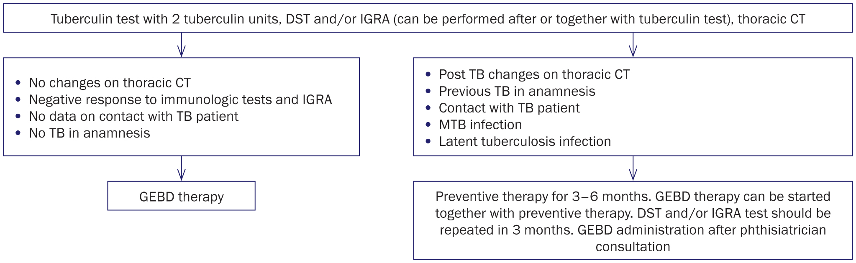

**Fig**. Action plan for doctors according to results of screening on latent tuberculosis before GEBD administration

*Note*. Thoracic CT — thoracic computer tomography, TB — tuberculosis, MTB — *M. tuberculosis*, GEBD — genetically engineered biologic drugs.

**Source**: Aksenova V.A. et al., 2020.

**STUDY LIMITATIONS**

The result of the study could be affected by the suppression of the fact that patients did not intake the prescribed preventive tuberculosis treatment. Children who were treated in hospitals on account of autoimmune disease may not have been classified as high risk of tuberculosis development and not referred to phthisiatrician consultation. It is possible due to the lack of necessary information, for example: incapability to perform immunology research (contradicted in case of uveitis), inaccurate anamnesis (contact with TB patient is not indicated). Another possible limitation is the absence (impossibility) of randomization at separation in groups, while it could minimize systematic error and researchers’ bias.

Our sample has showed fairly high infection rate of *M. tuberculosis* (93%), as well as the presence of latent tuberculosis infection in 7% of children. Meanwhile, nearly 30% of the world population is infected according to WHO [3]. Moreover, the coverage of this category of children with immunological screening using tubercular recombinant allergen is insufficient. There is no prescription of preventive tuberculosis treatment in children who really had indications.

FINANCING SOURCE

Not specified.

CONFLICT OF INTERESTS

Dmitry A. Kudlay is the employee of Generuim.

Other authors confirmed the absence of a reportable conflict of interests.