**Vladimir E. Mukhin1, Lyudmila L. Pankratyeva2, Olga I. Mileva3, Mikhael N. Yartsev4, Nikolay N. Volodin2**

1 Centre for Strategic Planning, Moscow, Russian Federation

2 Dmitry Rogachev National Medical Research Center of Pediatric Hematology, Oncology and Immunology, Moscow, Russian Federation

3 City Clinical Hospital № 24 (branch № 2), Moscow, Russian Federation

4 State Scientific Center «Institute of Immunology», Moscow, Russian Federation

**Absolute Neutropenia and Infection Development in Premature Infants in Early Neonatal Period: Cross-Sectional Study**

**Corresponding author:**

*Mukhin Vladimir E.*, leading analyst in the department for analysis and prediction of biomedical health risks in the Centre for Strategic Planning

**Address:** 119435, Moscow, Pogodinskaya Str., 10, build. 1, **phone:** +7 (495) 540-61-74 (add. 1122), **e-mail:** [muhinvldmr@gmail.com](mailto:muhinvldmr@gmail.com)

**Article received:** Sep 20, 2020, **accepted for publication**: Oct 23, 2020

***Background.*** *Premature infants have high risk of developing of neutropenia and infections in the early neonatal period. The correlation of these events requires further studies.* ***Objective.*** *The aim of the study was to investigate the frequency of absolute neutropenia and infectious complications cases in premature infants in the early neonatal period with estimation of phenotypical and functional features of cord blood neutrophils.* ***Methods.*** *The study included premature infants (gestational age 25–36 weeks) with APGAR score <8 on the 1st and 5th minutes of life. The frequency of absolute neutropenia (at least once <1.5×109/l) and infectious complications (localized infections of bacterial etiology, early neonatal sepsis) cases in the first 14 day of life was analysed. Additionally, we have determined the expression of CD64, CD16, CD32 by cord blood neutrophils in premature (n = 102) and mature infants (n = 30) via method of flow cytofluorometry. We have used FITC labeled Escherichia coli to estimate their phagocytic activity, and stimulation of E. coli neutrophils in the presence of 5 mM of dihydrorhodamine 123 to estimate their stimulation index (ratio of mean fluorescent intensity (MFI) of activated neutrophils in stimulated samples and in negative controls, E. coli free samples).* ***Results.*** *The episodes of absolute neutropenia in the first 14 days of life were recorded in 17 cases, infectious complications — in 87 children (in 24 cases — sepsis) in the group of premature infants. The frequency of infectious complications in premature children did not correlate with the frequency of absolute neutropenia episodes. Cord blood neutrophils in premature infants had higher CD64 expression and, on the contrary, lower CD16 expression, as well as low phagocytic activity and stimulation index value (in all cases p <0.001).* ***Conclusion****. Absolute neutropenia in premature infants in early neonatal period does not correlate with high risk of bacterial infections.* *However, cord blood neutrophils in premature infants had lower functional activity.*

***Key words:*** *absolute neutropenia, premature, bacterial infections, early neonatal period, phagocytosis, Fc-gamma receptors, respiratory burst*

***For citation:*** Mukhin Vladimir E., Pankratyeva Lyudmila L., Mileva Olga I., Yartsev Mikhael N., Volodin Nikolay N. Absolute Neutropenia and Infection Development in Premature Infants in Early Neonatal Period: Cross-Sectional Study. *Voprosy sovremennoi pediatrii — Current Pediatrics*. 2020; 19 (5): 352–358. doi: 10.15690/vsp.v19i5.2211

**RESULTS**

**Table 1**. Characteristics of premature and mature infants’ groups included to the study

|  |  |  |
| --- | --- | --- |
| **Indicators** | **Premature infants, *n* = 102** | **Mature infants, *n* = 30** |
| Gender (male), abs. (%) | 50 (49) | 14 (47) |
| Gestational age, weeks  *min* – *max* | 31 (28; 33)  25–36 | 39 (38; 39)  38–41 |
| Body weight, g  *min* – *max* | 1410 (1130; 1720)  690–2670 | 3395 (3230; 3667)  2430–3910 |
| APGAR, 1st min, score  *min* – *max* | 6 (5; 6)  4–7 | 8 (8; 8)  8–8 |
| APGAR, 5th min, score  *min* – *max* | 7 (7; 7)  6–7 | 9 (9; 9)  8–9 |

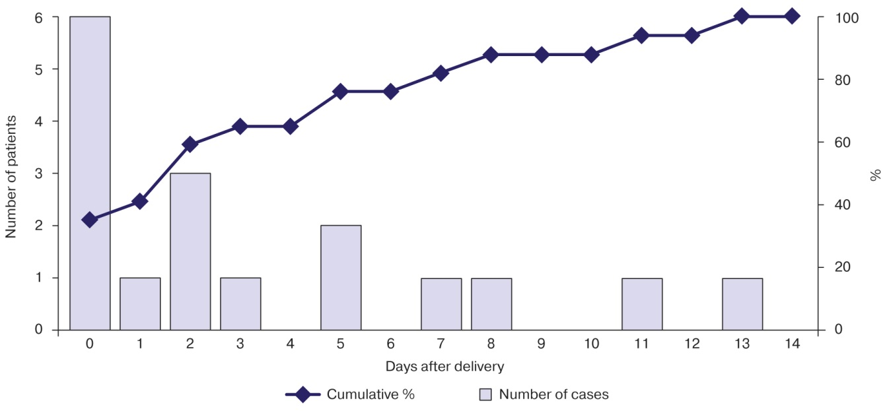

**Fig.**The age of first episode of absolute neutropenia in premature infants

**Table 2.** Comparative analysis of premature infants according to absolute neutropenia development

|  |  |  |  |
| --- | --- | --- | --- |
| **Indicators** | **AN(−), *n* = 85** | **AN(+), *n* = 17** | ***p*** |
| Gender (male), abs. (%) | 39 (46) | 11 (65) | 0,189 |
| Birth weight, g | 1420 (1180; 1760) | 1150 (910; 1670) | 0,028 |
| Gestational age, weeks | 31 (29; 33) | 29 (28; 31) | 0,309 |
| APGAR, 1st min, score | 6 (5; 7) | 6 (5; 6) | 0,047 |
| APGAR, 5th min, score | 7 (7; 7) | 7 (6; 7) | 0,252 |
| Intrauterine growth restriction syndrome, abs. (%) | 9 (11) | 7 (41) | 0,005 |
| Mother had during pregnancy, abs. (%)   * preeclampsia * ARI * exacerbation of chronic infection * urogenital infection * threatening miscarriage | 18 (21)  22 (26)  63 (74)  38 (45)  70 (82) | 5 (29)  6 (35)  13 (76)  10 (59)  15 (88) | 0,526  0,552  0,999  0,303  0,730 |
| Long period without amniotic fluid (>12 h), abs. (%) | 31 (36) | 4 (24) | 0,406 |
| Meconium in amniotic fluid, abs. (%) | 19 (22) | 5 (29) | 0,539 |

*Note*. AN(−)/(+) — premature infants without/with absolute neutropenia in first 14 days of life (at least once). ARI — acute respiratory infections.

**Table 3.**Risk of infectious complications and lethal outcome development in premature infants with absolute neutropenia

|  |  |  |  |
| --- | --- | --- | --- |
| **Indicators** | **AN(−), *n* = 85** | **AN(+), *n* = 17** | ***р*** |
| Localized infections, abs. (%) | 53 (62) | 10 (59) | 0,999 |
| Sepsis, abs. (%) | 19 (22) | 5 (29) | 0,756 |
| Mortality, abs. (%) | 9 (11) | 2 (12) | 0,999 |

*Note*. AN(−)/(+) — premature infants without/with absolute neutropenia in first 14 days of life (at least once).

**Table 4.** Phenotypical and functional features of cord blood neutrophils of premature and mature infants

|  |  |  |  |
| --- | --- | --- | --- |
| **Indicators** | **Premature infants, *n* = 102** | **Mature infants, *n* = 30** | ***р*** |
| CD64, MFI | 6,8 (5,25; 9,9) | 4,45 (3,0; 5,5) | 0,001 |
| CD32, MFI | 11,2 (7,8; 13,3) | 10,0 (7,1; 14,6) | 0,950 |
| CD16, MFI | 78,6 (70,9; 98,7) | 109,4 (89,4; 126,1) | 0,001 |
| Phagocytizing neutrophils, % | 81,9 (74,5; 86,8) | 92,5 (85,5; 94,9) | 0,001 |
| Stimulation index | 15,3 (11,5; 23,4) | 34,8 (29,9; 48,3) | 0,001 |

*Note*. MFI — mean fluorescent intensity. Stimulation index — comparative analysis of respiratory burst intensity (calculated as ratio of MFI of neutrophils stimulated by *E. coli*), to MFI of neutrophils of negative control (without E. *coli* stimulation*)*.

**Table 5.** Phenotypical and functional features of cord blood neutrophils of premature infants with different gestational age

|  |  |  |  |
| --- | --- | --- | --- |
| **Indicators** | **Gestational age** | | ***р*** |
| **25–31 weeks, *n* = 58** | **32–36 weeks, *n* = 44** |
| CD64, MFI | 7,4 (5,2; 10,7) | 6,65 (5,2; 9,6) | 0,537 |
| CD32, MFI | 11,6 (8,6; 13,2) | 10,1 (6,35; 13,5) | 0,381 |
| CD16, MFI | 75,7 (69,1; 88,7) | 90,8 (73,3; 114,9) | 0,046 |
| Phagocytizing neutrophils, % | 79,3 (70,2; 83,4) | 81,5 (78,1; 85,9) | 0,135 |
| Stimulation index | 11,3 (10,7; 13,4) | 23,90 (19,7; 31,1) | 0,001 |

*Note*. MFI — mean fluorescent intensity. Stimulation index — comparative analysis of respiratory burst intensity (calculated as ratio of MFI of neutrophils stimulated by *E. coli*), to MFI of neutrophils of negative control (without E. *coli* stimulation*)*.

**STUDY LIMITATIONS**

Direct comparison of the risk of infectious complications and lethal outcome development in premature infants without adjusting for interfering factors does not give complete understanding on correlation of absolute neutropenia and outcomes.

It should be taken into account that neutrophils show sensitivity to various changes in the external environment (including factors due to the blood sampling, their storage and transportation to the laboratory). All of that can lead to their spontaneous activation and damage of obtained results.

**FINANCING SOURCE**

Not specified.

**CONFLICT OF INTERESTS**

Not declared.