**Diana V. Sutovskaya, Alla V. Burlutskaya, Larisa V. Dubova, Daria R. Krylova**

Kuban State Medical University, Krasnodar, Russian Federation

**Immunological Protection of Individuals Aged 3 to 25 Years Against Pertussis: Regional Cross-Sectional Study**

**Corresponding author:**

*Sutovskaya Diana V.*, MD, PhD, associate professor in pediatric department № 2 of Kuban State Medical University

**Address**: 350063, Krasnodar, Mitrofan Sedin str., 4, **phone:** +7 (861) 268-54-18, **e-mail:** yablochkinad@mail.ru

**Article received**: Apr 02, 2020, **accepted for publication**: Feb 24, 2021

***Background.*** *Recently, there has been an increase in the incidence of pertussis in unvaccinated, as well as vaccinated children and adults. The major risk group for pertussis are infants and children over 4 years of age due to gradual decrease in basic immunity.* ***Objective****. The aim of the study was to analyze postvaccinal immunity against pertussis in individuals aged 3 to 25 years in Krasnodar.* ***Methods.*** *The study was carried out in the period between July 2018 and October 2019 and included patients aged 3 to 25 years with completed (according to National Immunization Schedule) immunization against pertussis with no history of pertussis in the past. Postvaccinal immunity against pertussis in this sample was determined by the ratio of study participants with minimum protective antibodies titer to Bordetella pertussis (≥ 1:160).* ***Results.*** *The minimum protective antibody titer was revealed in 24 out of 76 participants. Distribution to age groups was the following: children aged 3 to 7 years — 2/28 (7%), 8 to 17 years — 13/22 (59%; p < 0.001, compared with the younger age group), ≥ 18 years — 9/26 (35%; p = 0.017). There was no postvaccinal immunity (no antibodies detected) in 6 (21%), 1 (5%) and 4 (15%) participants, respectively.* ***Conclusion.*** *Insufficient postvaccinal (humoral) immunity against pertussis was revealed in majority of children under 7 years. The ratio of such children decreases with age. It suggests the presence of hidden circulation of Bordetella pertussis and, as a result, previous medical condition in erased or abortive form.*

***Key words:*** *children, pertussis, postvaccinal immunity, antibodies, Bordetella pertussis, National Immunization Schedule*

***For citation:*** Sutovskaya Diana V., Burlutskaya Alla V., Dubova Larisa V., Krylova Daria R. Immunological Protection of Individuals Aged 3 to 25 Years Against Pertussis: Regional Cross-Sectional Study. *Voprosy sovremennoi pediatrii — Current Pediatrics*. 2021;20(1):62–66. doi: 10.15690/vsp.v20i1.2237

**RESULTS**

**Table.** Postvaccinal immunity against pertussis

|  |  |  |  |  |
| --- | --- | --- | --- | --- |
| **Age groups** | **Total, abs.** | **No antibodies** | **Titer < 1:160** | **Titer ≥ 1:160** |
| 3–7 years, abs. (%) | 28 | 6 (21) | 20 (71)* | 2 (7) |
| 8–17 years, abs. (%) | 22 | 1 (5) | 8 (36) | 13 (59)*** |
| 18–25 years, abs. (%) | 26 | 4 (15) | 13 (50) | 9 (35)** |

*Note*. * *р* = 0,021 in comparison to the responders group aged 8 to 18 years, ** *p* = 0,017, *** *р* < 0,001 in comparison to the responders group aged 3 to 7 years.

Total values of patients ratio (%) with different antibody titers may be < 100 due to rounding of values to integers.

**Fig.** Level of protective antibodies to *B. pertussis* according to study participants’ age

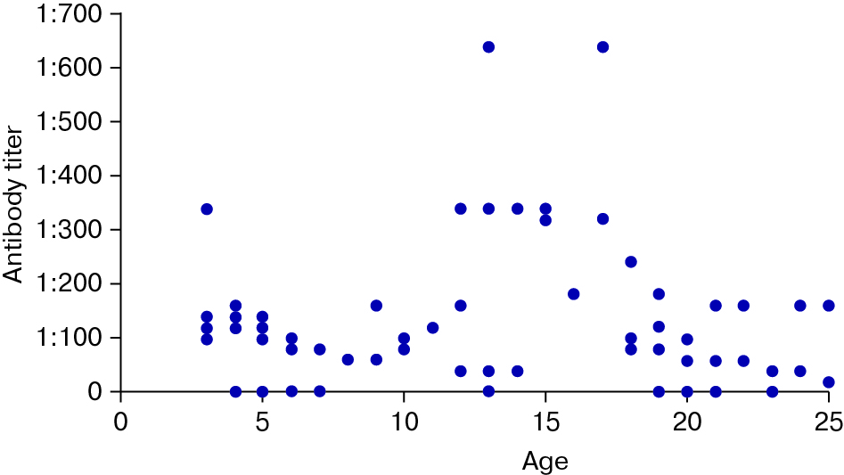

**STUDY LIMITATIONS**

The limitations of postvaccinal immunity research are small sample size (due to the fact that serological studies were carried out at the expense of the funds of the participants or their parents) and lack of comparison group. The comparison group could include children vaccinated with cell-free vaccine according to the National Immunization Schedule or children with incorrect vaccination schedule. Moreover, it should be noted that the study has included children without any somatic pathology or allergic diseases during the conducting of the research. Thus, it is impossible to estimate the status of immunity against pertussis in children with aggravated allergological history or with any chronic condition. Also, only children, whose parents supported vaccination and performed it at their own expense, have participated in the study.

Protective antibodies titer to *B. pertussis* may not reflect the quality of vaccination but may result from previous medical condition in erased or abortive form, and so not mentioned in medical records. It should also be taken into account that antibodies titer to *B. pertussis* reflects to humoral (antitoxic) immunity state against pertussis. Although, this part of immune system plays major role in postvaccinal protection against pertussis, we should not underestimate the role of cellular immunity (associated with anti-inflammatory interleukins 4 and 10 production). However, it is known that cellular immunity cannot effectively «compensate» lack or low level of antibodies to *B. pertussis* [20, 21]. In this regard, the main conclusion of the study on the lack of protection in children aged 3 to 7 years from pertussis still seems crucial to us.

**FINANCING SOURCE**

Vaccination and serological studies were carried out at the expense of the funds of the study participants (over 18 years) or their parents or legal representatives.

**CONFLICT OF INTERESTS**

Not declared.