**Elena N. Kulakova1, Tatjana L. Nastausheva1, Inna V. Kondratjeva1, Tatjana G. Zvyagina1, 2, Maria P. Koltakova1**

1Voronezh State Medical University n.a. N.N. Burdenko, Voronezh, Russian Federation

2 Voronezh Regional Children's Clinical Hospital № 1, Voronezh, Russian Federation

**Transition of Adolescents with Chronic Kidney Disease to Adult Health Service: Scoping Review**

**Corresponding author:**

*Kulakova Elena N.*, MD, PhD, associate professor in hospital and outpatient pediatrics department of Voronezh State Medical University n.a. N.N. Burdenko

**Address:** 394036, Voronezh, Studencheskaya str., 10, **phone**: +7 (473) 237-27-46, **e-mail:** elena.n.kulakova@mail.ru

**Article received:** Jul 14, 2020, **accepted for publication:** Feb 24, 2021

***Background.*** *The transition of adolescents with chronic diseases from pediatric to adult health service is often accompanied by a decrease in adherence to the recommendations, non-regular scheduled medical consultations, disease course monitoring violation. All together it can lead to exacerbation and progression of the chronic disease and a decrease in quality of life. Programs for patients with nephrological diseases that optimize the process of their transition to adult service can improve the course of chronic kidney disease (according to international experts).* ***Objective.*** *The aim of the study was to systematize data from the published literature on the transition of adolescents with chronic kidney disease to adult health service; identify gaps in scientific knowledge; and determine areas for future research.* ***Methods.*** *Scoping review was performed by searching for articles in the databases: PubMed, eLIBRARY.RU, The Cochrane Library, via Google Scholar and in reference lists of selected articles. We have selected articles published in Russian or English with no publication date limitation and corresponding to inclusion criteria.* ***Results.*** *185 (8.5%) out of 2,184 identified literature sources were included in the study. The results of 25 works were included in the analysis of transition programs efficacy. There were no Russian-language articles matching the inclusion criteria. The majority of publications types were original scientific studies (retrospective observational studies, questionnaire surveys, qualitative and mixed methods studies with interviewing) and narrative reviews. It was shown that both complex programs and narrow-focus interventions have been implemented to improve the transition process. It has been noted that the efficacy of such initiatives still remains insufficiently studied, including among experimental studies.* ***Conclusion.*** *Formation of the scientific knowledge system on the transition of patients with chronic kidney disease to adult health service requires high-level evidence. Further researches are needed in this field in the Russian health system as well.*

***Key words:*** *adolescents, transition, healthcare, chronic kidney disease, scoping review*

***For citation:*** Kulakova Elena N., Nastausheva Tatjana L., Kondratjeva Inna V., Zvyagina Tatjana G., Koltakova Maria P. Transition of Adolescents with Chronic Kidney Disease to Adult Health Service: Scoping Review. *Voprosy sovremennoi pediatrii — Current Pediatrics*. 2021;20(1):38–50. doi: 10.15690/vsp.v20i1.2235

**RESULTS**

**Fig. 1.** Flow chart of identification and selection of articles for the systematic review literature study

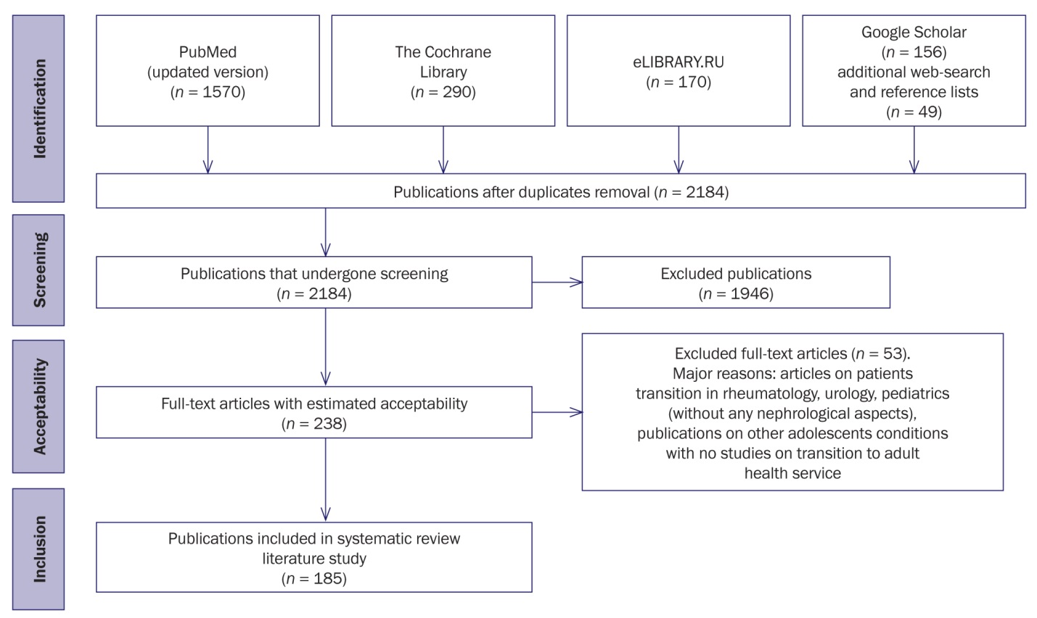

**Table 1.**Summary on selected publications

|  |  |  |
| --- | --- | --- |
| **Category** | **Characteristics** | **Number, abs. (%)** |
| Publication dates | 1985–1999 | 3 (1,6) |
| 2000–2009 | 27 (14,6) |
| 2010–2014 | 56 (30,8) |
| 2015–05.2020 | 99 (53,0) |
| Countries | International collaboration | 32 (17,3) |
| USA | 67 (36,2) |
| Great Britain | 25 (13,5) |
| Canada | 17 (9,2) |
| Australia | 9 (4,9) |
| Netherlands | 6 (3,2) |
| Germany | 6 (3,2) |
| Japan | 6 (3,2) |
| Spain | 3 (1,6) |
| Finland | 3 (1,6) |
| Switzerland | 2 (1,1) |
| Belgium, Nigeria, Portugal, Turkey, Philippines, France, South Africa, Israel, India | One publication |
| Journal’s name with ≥ 5 published articles | Pediatric Nephrology | 17 (9,2) |
| Pediatric Transplantation | 15 (8,1) |
| Advances in Chronic Kidney Disease | 10 (5,4) |
| Progress in Transplantation | 7 (3,8) |
| Nephrology Dialysis Transplantation | 9 (4,9) |
| Journal of Pediatric Nursing | 9 (4,9) |
| Clinical and Experimental Nephrology | 5 (2,7) |
| Kidney International | 5 (2,7) |
| Nephrology Nursing Journal | 5 (2,7) |

**Fig. 2.**Distribution of selected articles according to year of publication

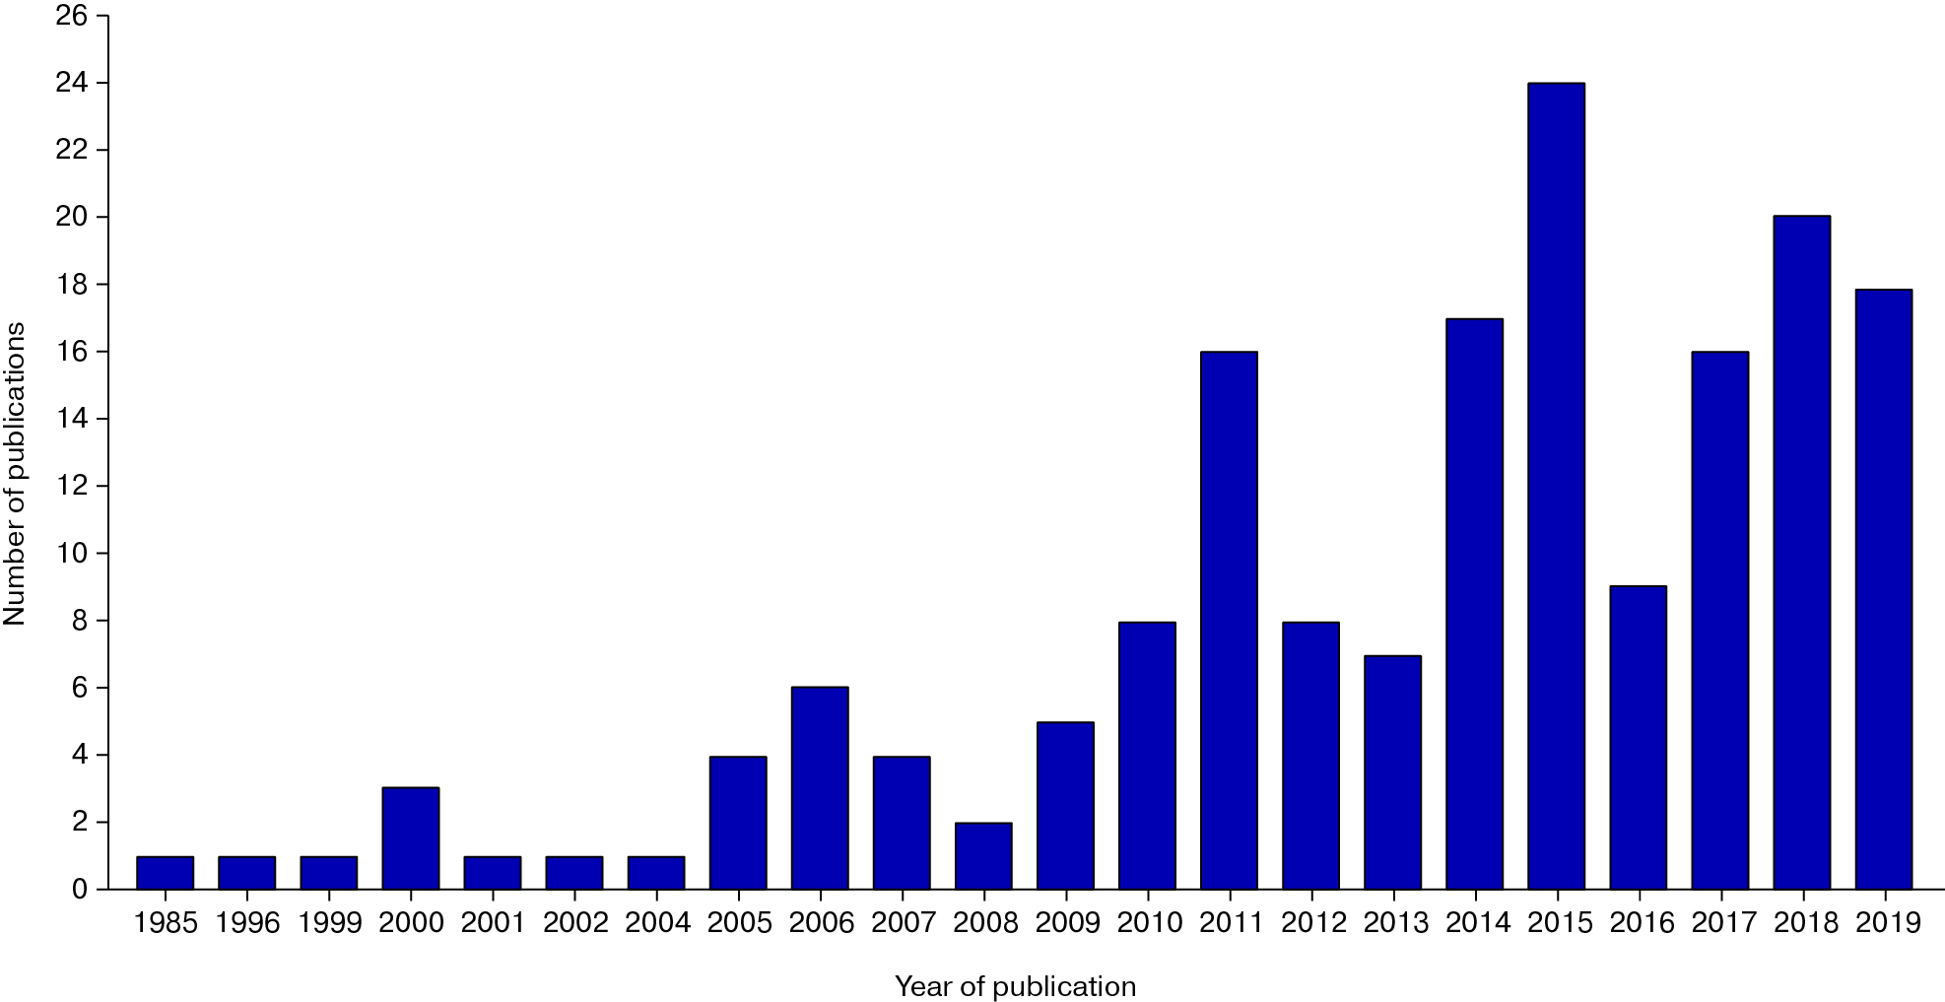

**Table 2.**The major publications types

|  |  |  |
| --- | --- | --- |
| **№** | **Publication type** | **Number, abs. (%)** |
| 1 | Results of original scientific researches | 96 (51,9) |
| * Retrospective observational study with various design on available medical records and/or patients registries (*n* = 34) |
| * Questionnaire surveys of adolescents, their parents and/or medical staff (*n* = 35) |
| * Qualitative and comprehensive studies (leading method – interviewing) (*n* = 27) |
| 2 | Descriptive reviews | 39 (21,1) |
| 3 | Experts’ opinions, editorial articles | 15 (8,1) |
| 4 | Description of initiatives on transition process improvement used in clinical practice | 12 (6,5) |
| 5 | Consensus papers and guidelines of professional health organizations | 9 (4,9) |
| 6 | Systematic review literature study | 7 (3,8) |
| 7 | Protocols of randomized controlled studies and programs ready for implementation | 4 (2,1) |
| 8 | Clinical case report | 3 (1,6) |

**Table 3.** The major directions of the implemented initiatives on transition process improvement

|  |  |  |  |  |  |
| --- | --- | --- | --- | --- | --- |
| **Initiatives** | **Country** | **Year** | **Study design\*** | **Efficacy\*\*** | **Reference** |
| Complex programs of adolescent support during transition to adult health service | Finland | 2019 | Retrospective observational analytical | No | [27] |
| USA | 2019 | Not performed | – | [28] |
| USA | 2019 | Not performed | – | [29] |
| Germany | 2019 | Not performed | – | [30] |
| Great Britain | 2015 | Not performed | – | [31] |
| Switzerland | 2015 | Retrospective observational analytical | Yes | [32] |
| Netherlands | 2014 | Descriptive | Yes | [33] |
| USA | 2012 | Not performed | – | [34] |
| Australia | 2009 | Descriptive | Yes | [35] |
| Canada | 2006 | Not performed | – | [36] |
| Great Britain | 2006 | Descriptive | Yes | [37] |
| Transition clinics and/or clinics for young adults | Canada | 2019 | Comprehensive design (questionnaires, interview) | Yes | [38] |
| Australia | 2015 | Comprehensive design (questionnaires, interview) | Yes | [39] |
| Canada | 2015 | Retrospective observational analytical | Yes | [15] |
| Germany | 2013 | Retrospective observational analytical | Yes | [40] |
| Canada | 2012 | Retrospective observational analytical | Yes | [41] |
| Great Britain | 2012 | Retrospective observational analytical | Yes | [14] |
| Camp out of medical facility (2–7 days) | Netherlands | 2013 | Comprehensive design (questionnaires, interview) | Yes | [42] |
| Transition coordinator*** | USA | 2015 | Retrospective observational analytical | No | [26] |
| Questionnaires on transition readiness | USA | 2009 | Not performed | – | [43] |
| Online education | Canada | 2015 | Comprehensive design (questionnaires, interview) | Yes | [44] |
| Mentoring | USA | 2020 | Comprehensive design (questionnaires, interview) | Yes | [45] |
| South Africa | 2017 | Not performed | – | [46] |
| Great Britain | 2010 | Not performed | – | [47] |
| Psychological support, coaching | Netherlands | 2014 | Qualitative (interview) | Yes | [48] |

*Note.*\* Cohort studies (historical control included) were classified as observational analytical; studies without comparison group with questionnaire survey as a major method – as descriptive [23, 24]. ** “Yes” — study results have demonstrated the improvement in transition results after initiative implementation; “No” — the efficacy was not confirmed; “–“ — the efficacy was not studied.*** Transition coordinator is the employee providing preparation and coordination of transition process of adolescents to adult health service.

**Fig. 3.** Patient-oriented conceptual model of adolescents transition from pediatric to adult health service

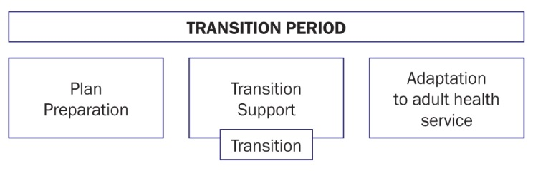

**STUDY LIMITATIONS**

We did not register and publish the protocol. The search was limited by PubMed, eLIBRARY, Cochrane Library, Google Scholar and reference lists of selected articles. Screening of article titles and abstracts was performed by one author without any critical evaluation of the quality of the selected studies and publications. These limitations may lead to formation of incomplete publication database that does not represent all research and publication activity on the topic. The absence of the methodological quality assessment of researches does not allow us to make reliable conclusion on the efficacy of the initiatives presented in publications to improve the process of adolescents transition to the adult health service. However, it should be noted that review studies performed using the scoping review methodology are conducted to examine all available literature that meets the inclusion criteria using descriptive-analytical approach. Moreover, they do not require mandatory assessment of the studies quality and do not involve meta-analysis. Whereby, the summarized and structured information presented in the review study results allows to identify the gaps in the scientific knowledge system, to determine further research trends and to develop initiatives for improving the quality of medical care.

**FINANCING SOURCE**

Not specified.

**CONFLICT OF INTERESTS**

Not declared.