Tatiana S. Kashinskaya, Natalia V. Shakhova

Altai State Medical University, Barnaul, Russian Federation

Association Between 25(ОН)D Concentration and Atopic Dermatitis and Its Severity Children Aged from 3 to 6 Years: Cross Sectional Study

Corresponding author:
Kashinskaya Tatiana S., teaching assistant of children diseases propedeutics department in Altai State Medical University
Address: 656038, Barnaul, Lenin avenue, 40, phone: +7 (385) 261-91-82, e-mail: kashinskaya_agmu@mail.ru
Article received: 09.03.2021, accepted for publication: 25.06.2021

Background. The association between the vitamin D provision for children and the atopic dermatitis (AD) development and severity is not clearly determined. Objective. The aim of the study was to compare 25(OH)D serum concentration in children with AD and in healthy peers with association analysis of 25(OH)D with disease severity and allergen sensibilization. Methods. The study included children aged from 3 to 6 years with AD and their healthy peers. Vitamin D provision was estimated via 25(OH)D serum concentration determined by chemiluminescent microparticle immunoassay. Vitamin D deficiency was established at 25(OH)D concentration ≤20 ng/ml, insufficiency — 21–29 ng/ml. Sensibilization to airborne (Dermatophagoides pteronyssinus, Dermatophagoides farinae, cat epithelium and dandruff) and food (cow's milk and chicken egg proteins) allergens was determined by IgE concentration revealed via immunofluorescence. Results. The 25(OH)D serum concentration in children with AD (n = 106) was lower than in their healthy peers (n = 40), median (interquartile range) — 26.5 ng/ml (19.0–35.3) and 32.4 ng/ml (27.9–37.5) respectively (p = 0.012). Meanwhile, vitamin D insufficiency/deficiency according to 25(OH)D concentration was revealed in more than half patients (58%) with AD and in every third child (37%) from control group (OR — 3.5, 95% CI — 1.6–7.5). It was also revealed that 25(OH)D concentration was lower in patients with moderate course of AD (in comparison to mild) as well as in children sensibilized to airborne and/or food allergens. Conclusion. The vitamin D provision in preschool children is associated with AD, its severity and the presence of sensibilization to airborne and/or food allergens.
Key words: atopic dermatitis, vitamin D, insufficiency, deficiency, 25(ОН)D, children, preschool age
For citation: Kashinskaya Tatiana S., Shakhova Natalia V. Association Between 25(ОН)D Concentration and Atopic Dermatitis and Its Severity Children Aged from 3 to 6 Years: Cross Sectional Study. Voprosy sovremennoi pediatrii — Current Pediatrics. 2021;20(3):232–237. doi: 10.15690/vsp.v20i3/2273

RESULTS
Table 1. Characteristics of children with AD (n = 106)
Indicators | Values
Severity, abs. (%)  - mild  - moderate  - severe | 65 (61)  41 (39)  –
Sensibization, abs. (%)  - airborne allergens  - food allergens  - airborne and food allergens  - sensibization to ≥2 antigens | 42 (40)  30 (28)  24 (23)  27 (25)
Sensibization spectrum, abs. (%)  - Dermatophagoides pteronyssinus  - Dermatophagoides farinae  - cow's milk protein  - chicken egg protein  - cat epithelium and dandruff | 17 (18)  7 (7)  24 (23)  20 (19)  37 (35)

Table 2. 25(ОН)D serum concentration in patients aged from 3 to 6 years with AD and in healthy peers
Indicators | Children with AD (n = 106) | Control group (n = 40) | р
25(ОН)D, ng/ml  - ≤ 20  - 21–29  - 30–100  - > 100 | 24,4 (18,9; 30,2)  37 (35%)  35 (33%)  34 (32%)  0 | 32,4 (27,9; 37,5)  0  15 (37%)  25 (63%)  0 | 0,001  0,001
Note. 25(ОН)D concentration was higher than analytical sensitivity level of the detection method in all study participants (> 4 ng/ml)

Figure. Correlation between 25(ОН)D concentration and TIS index in children with AD
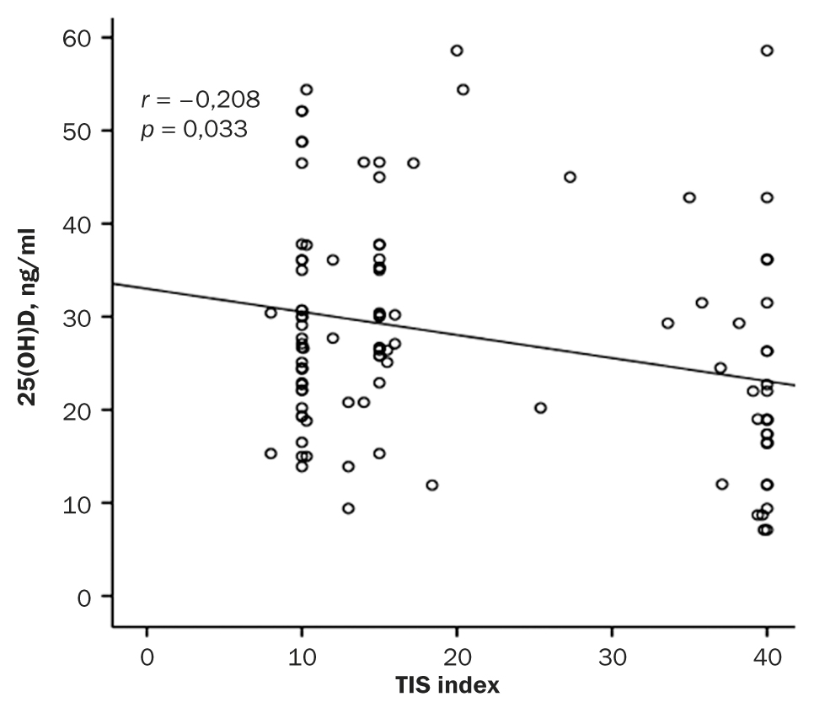

STUDY LIMITATIONS
The results of this study cannot be extrapolated to children with AD from other age groups (under 3 and over 6 years old). All children with AD in our study have attended preschool, thus long stay indoors may have affected the concentration of 25(OH)D. Moreover, we set aside children dietary habits as well as the fact that some children took vitamin D3. However, all children with 25(OH)D insufficiency or deficiency have received recommendations on vitamin D intake according to national program [23]. We had no children with severe AD in our study, but we can assume (according to study results [25]) that 25(OH)D concentration in majority of these patients would be < 20 ng/ml. It should also be noted that groups of children with AD and healthy peers were comparable in terms of enrollment (> 40% of all participants enrolled in the winter months). However, 25(OH)D concentration in children with AD during the summer season was higher than in healthy children presumably due to greater sun exposure [26]. Hence, it may happen that any differences in 25(OH)D concentration were not detected while forming representative sample by including patients during the summer period.

ACKNOWLEDGEMENTS
The authors express gratitude to allergists A.D. Fink (Barnaul) and A.G. Petrov (Biysk) and all laboratory department of KDL for all the assistance during the study.

FINANCING SOURCE
The study was funded by rector’s grant (rector of Altai State Medical University) (decree № 1048-pk, date: 19.12.19).

DISCLOSURE OF INTEREST
Not declared.

