**Irina Yu. Pronina1, 2, Nikolay N. Murashkin1, 3, 4, Svetlana G. Makarova1, 5, Elena L. Semikina1, Dmitry S. Yasakov1, Stepan G. Grigoriev6**

1 National Medical Research Center of Children’s Health, Moscow, Russian Federation

2 National Medical Research Center of Endocrinology, Moscow, Russian Federation

3 Sechenov First Moscow State Medical University (Sechenov University), Moscow, Russian Federation

4 Central State Medical Academy, Moscow, Russian Federation

5 Lomonosov Moscow State University, Moscow, Russian Federation

6 Pediatric Research and Clinical Center for Infectious Diseases, St. Petersburg, Russian Federation

**Vitamin D Provision in Children with Congenital Epidermolysis Bullosa: Cross-Sectional Study**

**Corresponding author:**

*Pronina Irina Yu.*, junior researcher in department of preventive pediatrics, nutritionist in National Medical Research Center of Children’s Health, endocrinologist in National Medical Research Center of Endocrinology

**Address:** 119296, Moscow, Lomonosovsky Ave., 2, b. 1, **e-mail:** krapchatovaiv@yandex.ru

**Article received:** Oct 18, 2020, **accepted for publication:** Oct 22, 2021

***Background.*** *Children with congenital epidermolysis bullosa (CEB) can have vitamin D deficiency due to its malabsorption in intestine and reduced synthesis in skin as these patients have restrictions on staying in the sun. However, the prevalence of vitamin D insufficiency/deficiency among patients with CEB remains not fully studied due to the small samples’ sizes in previously studies.* ***Objective****. Our aim was to study vitamin D provision in children with CEB.* ***Methods.*** *The study included children aged from 3 to 18 years old with simplex and dystrophic types of CEB hospitalized in our department. The serum level of 25(OH)D was determined via chemiluminescence immunoassay. Vitamin D deficiency was established at 25(OH)D concentration of 20-30 ng/ml, deficiency — < 10*–*20 ng/ml, deep deficiency — < 10 ng/ml.* ***Results.*** *The study included 129 children with CEB (62 (48%) males, median age 6 (3; 10) years). 101 patients had dystrophic type of disease, 28 — simplex.* *The median 25(OH)D serum concentration in children with CEB was 21.7 (13.0; 36.6) ng/ml. Vitamin D insufficiency was revealed in 36 (28%) patients, deficiency — in 38 (29%), deep deficiency — in 16 (12%). Independent predictors of 25(OH)D concentration were the type of CEB (concentration was higher in children with simplex type) and age (negative association), but not the patients’ gender and the examination season, according to multivariate regression analysis.* ***Conclusion.*** *The study has shown low level of vitamin D provision in children with CEB, whilst 25(OH)D concentration depended on the type of disease and the age of patients.*

***Keywords:*** *vitamin D, insufficiency, deficiency, congenital epidermolysis bullosa, children*

***For citation:*** Pronina Irina Yu., Murashkin Nikolay N., Makarova Svetlana G., Semikina Elena L., Yasakov Dmitry S., Grigoriev Stepan G. Vitamin D Provision in Children with Congenital Epidermolysis Bullosa: Cross Sectional Study. *Voprosy sovremennoi pediatrii — Current Pediatrics*. 2021;20(5): 407–412. (In Russ.) doi: 10.15690/vsp.v20i5.2315

**RESULTS**

**Table 1**.25(ОН)D concentration according to the CEB type, patients’ gender, and examination season

|  |  |  |  |
| --- | --- | --- | --- |
| **Indicators** | **25(OH)D, ng/ml** | **Vitamin D** **deficiency*, abs. (%)** | ***р*\*\*** |
| CEB type:   * simplex (*n*= 28) * dystrophic (*n*= 101) | 29,4 (22,2; 41,5)  20,0 (12,1; 30,3) | 4 (14)  50 (49,5) | < 0,001 |
| Gender:   * male (*n*= 62) * female (*n*= 67) | 22,2 (15,7; 36,6)  21,2 (12,3; 36,6) | 24 (39)  30 (45) | 0,557 |
| Season:   * autumn (*n*= 42) * winter (*n*= 21) * spring (*n*= 17) * aummer (*n*= 49) | 21,4 (15,7; 37,0)  19,8 (12,0; 21,4)  22,1 (12,7; 32,9  22,3 (22,3; 38,9) | 18 (43)  11 (52)  8 (47)  17 (35) | 0,306 |

*Note.* <*> — vitamin D deficiency was established at 25(OH) concentration <20 ng/ml (according to manufacturer's instruction); <**> — *р*-value is calculated at comparing quantitative indicators (Mann–Whitney test for two isolated groups, Kruskal–Wallis test for four groups).

**Fig**. Correlation analysis between age of children with CEB and 25(ОН)D concentration

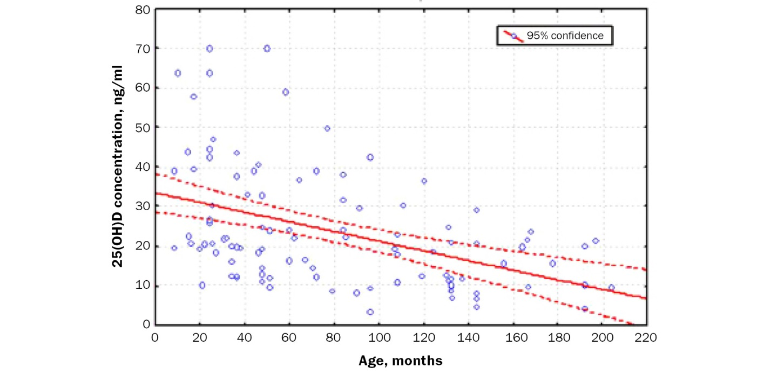

*Note*. Regression equation: y = 35,015 − 0,11 × х, where y — 25(ОН)D concentration, х — patients’ age. Correlation ratio *r* = −0,437 (*р* < 0,001). Full line graph is the line of regression showing calculated values of 25(ОН)D concentration for certain age, dotted line shows 95% confidential interval.

**Table 2**. Multivariate regression analysis of correlation between CEB type, gender, age, examination season and 25(ОН)D concentration

|  |  |  |
| --- | --- | --- |
| **Indicators** | **Regression coefficient** | ***р*** |
| CEB type (dystrophic — 1, simplex — 2) | 10,62 | < 0,001 |
| Gender (male — 1, female — 2) | −1,54 | 0,540 |
| Age, years | −1,41 | < 0,001 |
| Hospitalization season (autumn — 1, winter — 2, spring — 3, summer — 4) | 0,45 | 0,646 |
| Intercept | 23,69 | 23,69 |

*Note*. The model is statistically significant (*p* < 0,001), determination coefficient *R*2 = 0,216, in other words the degree of impact of analysed indicators on dispersion of 25(OH)D concentration is 21.6%. Statistical characteristics of the model did not change when the statistically insignificant indicators (child gender, hospitalization season) were excluded from the model (*p* < 0,001; *R*2 = 0,213).

**STUDY LIMITATIONS**

The study did not consider the patients nutrition issues, dose, and regularity of vitamin D intake (including nutrition formulas). However, only 4% of included patients regularly took vitamin D medications, thus, we believe that it is possible to neglect this fact in the concept of the conducted study.

The study did not analyze the effects of such factors as patients' physical activity and physical development on vitamin D levels. It indicates the limitation in the consideration of CEB type and patients age as independent predictors of 25(OH)D concentration and, consequently, vitamin D provision.

Most of the children included in the study had dystrophic type of CEB. These patients are characterized by significant violation of nutritional status and require active dietary support (due to the multi-organ nature of the lesion), unlike children with simple type of disease. Therefore, we should carefully extrapolate the obtained data on the entire population of patients with CEB, as ratio of patients with simplex type could be higher than in this study.

**FINANCING SOURCE**

The study was funded by “BELA. Butterfly Children” foundation.

**DISCLOSURE OF INTEREST**

**Nikolay N. Murashkin** — receiving research grants from pharmaceutical companies Janssen, Eli Lilly, Novartis. Scientific consultant of Galderma, Pierre Fabre, Bayer, LEO Pharma, Pfizer, AbbVie, Amryt Pharma, Zeldis Pharma.

The other contributors confirmed the absence of a reportable conflict of interests.