**Nikolay N. Murashkin1, 2, 3, Roman V. Epishev1, Olga S. Orlova1, 4, 5, Alena A. Kuratova5, Victoriya S. Polenova5**

1 National Medical Research Center of Children’s Health, Moscow, Russian Federation

2 Sechenov First Moscow State Medical University, Moscow, Russian Federation

3 Central State Medical Academy of Department of Presidential Affairs, Moscow, Russian Federation

4 Research and Clinical Institute for Children, Moscow, Russian Federation

5 Charitable foundation “BELA. Butterfly Children”, Moscow, Russian Federation

**Congenital Epidermolysis Bullosa Epidemiology among Children of Russian Federation**

***Background.*** *The prevalence of all types of congenital epidermolysis bullosa (СEB) worldwide is approximately 11 cases per 1 million according to the latest data from the American Epidermolysis Bullosa Registry. Data on the prevalence of СEB in Russian Federation is scattered, while data on life expectancy and mortality for this this disease is absent. This article presents medical and epidemiological data on children with СEB in Russian Federation.* ***Objective. The aim of the study is to*** *analyze clinical and epidemiological features of children with СEB in Russian Federation.* ***Methods.*** *We have performed analysis of the clinical and epidemiological features among pediatric population of Russian Federation with СEB using the “Registers of Genetic and Other Rare Diseases” of the “Butterfly Children” charitable foundation.* ***Results.*** *There are 491 children with СEB in Russian Federation as of 2024 according to the national registry data from “Registers of Genetic and Other Rare Diseases” of the “Butterfly Children” charitable foundation. The ratio of boys and girls was 1.08:1, that is relevant to the global data. The prevalence of CEB in children aged from 0 to 17 years in Russian Federation is 15.48 cases per 1,000,000 children as of January 1, 2024. The highest number of children with CEB were revealed in the Republic of Dagestan — 54 (11%) children, which is apparently due to the high rate of consanguineous marriages (50%). Other regions with high prevalence are Moscow Region (n=28, 5.7%), Moscow (n=25, 5.1%), Saint Petersburg (n=26, 5.2%) and Krasnodar Territory (n=23, 4.6%). Largest age group of children (from 12 to 18 years) includes 146 patients with mean age of 14.32±1.72 years. The most common form of CEB is dystrophic one — 261 patients, the next one is simplex — 191 patients, then junctional form — 31 patient, and Kindler syndrome — 8 patients. The birth rate of children with CEB by year during the period from 2019 to 2023 (per 100,000 children born): 2019 — 1.42, 2020 — 2.09, 2021 — 2.65, 2022 — 2.76 and 2023 — 1.74. The arithmetic mean birth rate of children with CEB over a five-year period was 2.13 cases per 100,000 children born. The registry contains information on 22 deceased patients, average age was 3.06 ± 4.66 (from 0 to 15 years, median 0.54 years). The highest number of fatal outcomes was observed in the Republic of Dagestan (n=3). Junctional CBE dominates in fatal outcomes among all the CEB types — 59.1% (n = 13 cases, 0.40 ± 0.22 years). The highest mortality was observed in I age group (from 0 to 1 year), which is 65.2% (15 fatal outcomes). Multisystem organ failure resulting from sepsis was the most common cause of death in both types of CEB (junctional and dystrophic). The mortality trend in the junctional form of CEB shows a decline in mortality, while the dystrophic type shows a stable situation during 2021–2023 years — 2 fatal outcomes per year. Junctional CEB has higher mortality rate at early age: survival curve shows sharp decline in the first months of life indicating high mortality in early life. The probability of survival drops to almost 0% in the first 100 days. Higher survival rate is more specific for the dystrophic type of CEB.* ***Conclusion.*** *This study demonstrates the significance and necessity to create and maintain registers for rare (orphan) diseases. Registry maintenance is an effective model for real understanding of the number of patients and value of needed assistance from the government to this category of patients.*

***Keywords****: congenital epidermolysis bullosa, epidemiology, prevalence, lifetime, mortality, children*

**For citation:** Murashkin Nikolay N., Epishev Roman V., Orlova Olga S., Kuratova Alena A., Polenova Victoriya S. Congenital Epidermolysis Bullosa Epidemiology among Children of Russian Federation. Voprosy sovremennoi pediatrii — Current Pediatrics. 2024;23(5):0–00. doi: https://doi.org/10.15690/vsp.v23i5.2808

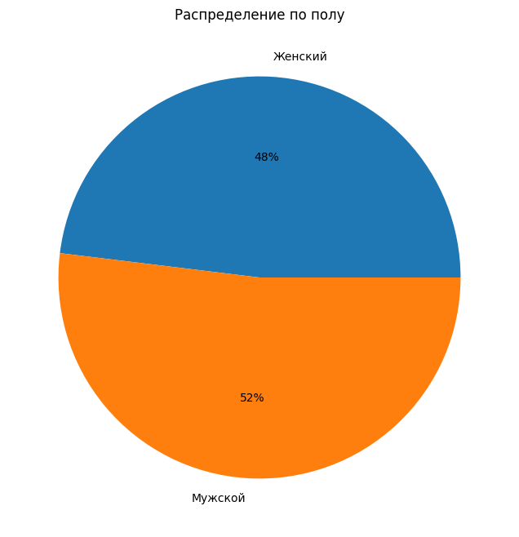

**Fig. 1.** Gender distribution of children with congenital epidermolysis bullosa

Gender distribution / female / male

**Table 1.** Number of children with all types of congenital epidermolysis bullosa

|  |  |  |  |
| --- | --- | --- | --- |
| **Diagnosis type** | **Gender** | **Quantity** | ***Mean ± std*, mean age of patients** |
| Dystrophic CEB | Female | 129 (26,3%) | 8,99 ± 4,79 |
| Male | 132 (26,9%) | 8,63 ± 5,03 |
| CEB simplex | Female | 93 (18,9%) | 7,98 ± 4,84 |
| Male | 98 (19,9%) | 7,38 ± 4,68 |
| Junctional CEB | Female | 11 (2,2%) | 5,45 ± 5,16 |
| Male | 20 (4,1%) | 4,22 ± 5,20 |
| Kindler syndrome | Female | 3 (0,6%) | 11,67 ± 2,52 |
| Male | 5 (1,1%) | 11,2 ± 6,1 |

**Fig. 2.** Distribution of children with congenital epidermolysis bullosa by nationality

Nationalities of children with CEB

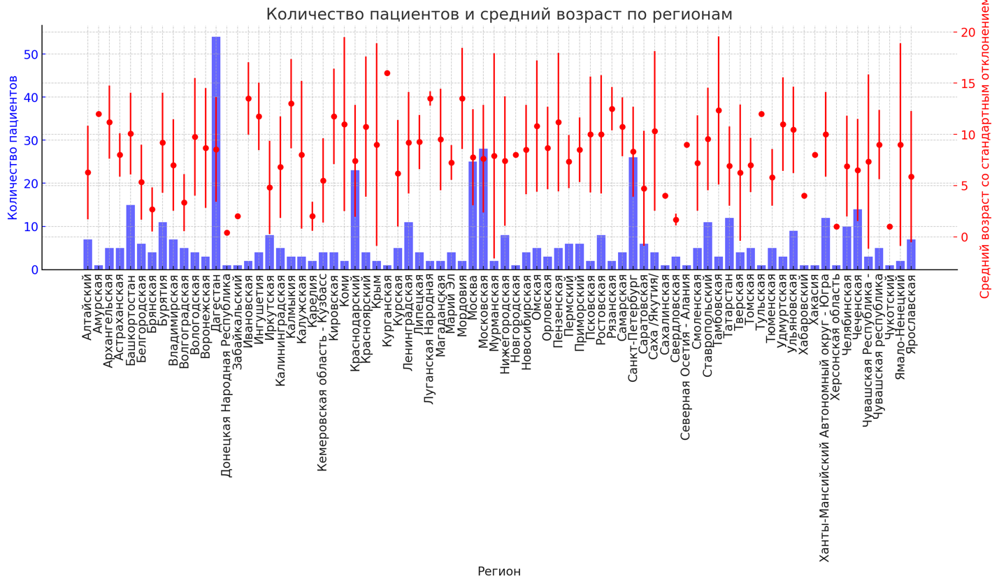

**Fig. 3.** Number of patients and mean age of children with congenital epidermolysis bullosa by regions

*Note.* Blue color — number of patients in the region, red lines - age of patients with mean value (point).

Number of patients / number of patients and mean age by region / mean age with standard deviation / region

**Fig. 4.** Distribution of congenital epidermolysis bullosa by type among children from 0 to 1 year of age

Junctional epidermolysis bullosa

Dystrophic epidermolysis bullosa

Epidermolysis bullosa simplex

**Fig. 5.** Distribution of congenital epidermolysis bullosa by type among children from 1 tear to 2 years 11 months 29 days

Junctional epidermolysis bullosa

Dystrophic epidermolysis bullosa

Kindler syndrome

Epidermolysis bullosa simplex

**Fig. 6.** Distribution of congenital epidermolysis bullosa by type among children from 3 years to 6 years 11 months 29 days

Junctional epidermolysis bullosa

Dystrophic epidermolysis bullosa

Epidermolysis bullosa simplex

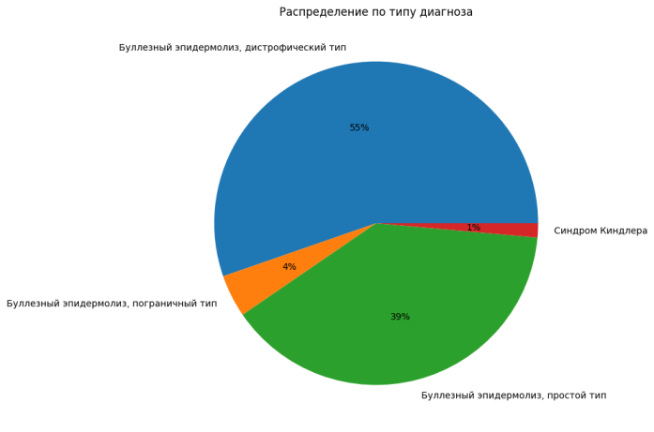

**Fig. 7.** Distribution of congenital epidermolysis bullosa by type among children from 7 years to 11 years 11 months 29 days

Junctional epidermolysis bullosa

Dystrophic epidermolysis bullosa

Kindler syndrome

Epidermolysis bullosa simplex

**Fig. 8.** Distribution of congenital epidermolysis bullosa by type among children from 12 years to 17 years 11 months 29 days

Junctional epidermolysis bullosa

Dystrophic epidermolysis bullosa

Kindler syndrome

Epidermolysis bullosa simplex

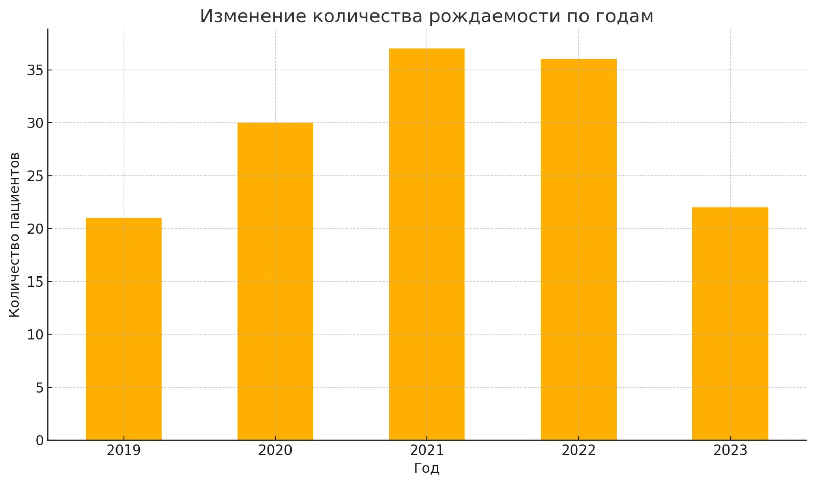

**Fig. 9.** Number of children with congenital epidermolysis bullosa born between 2019-2023, absolute numbers

Number of patients / year

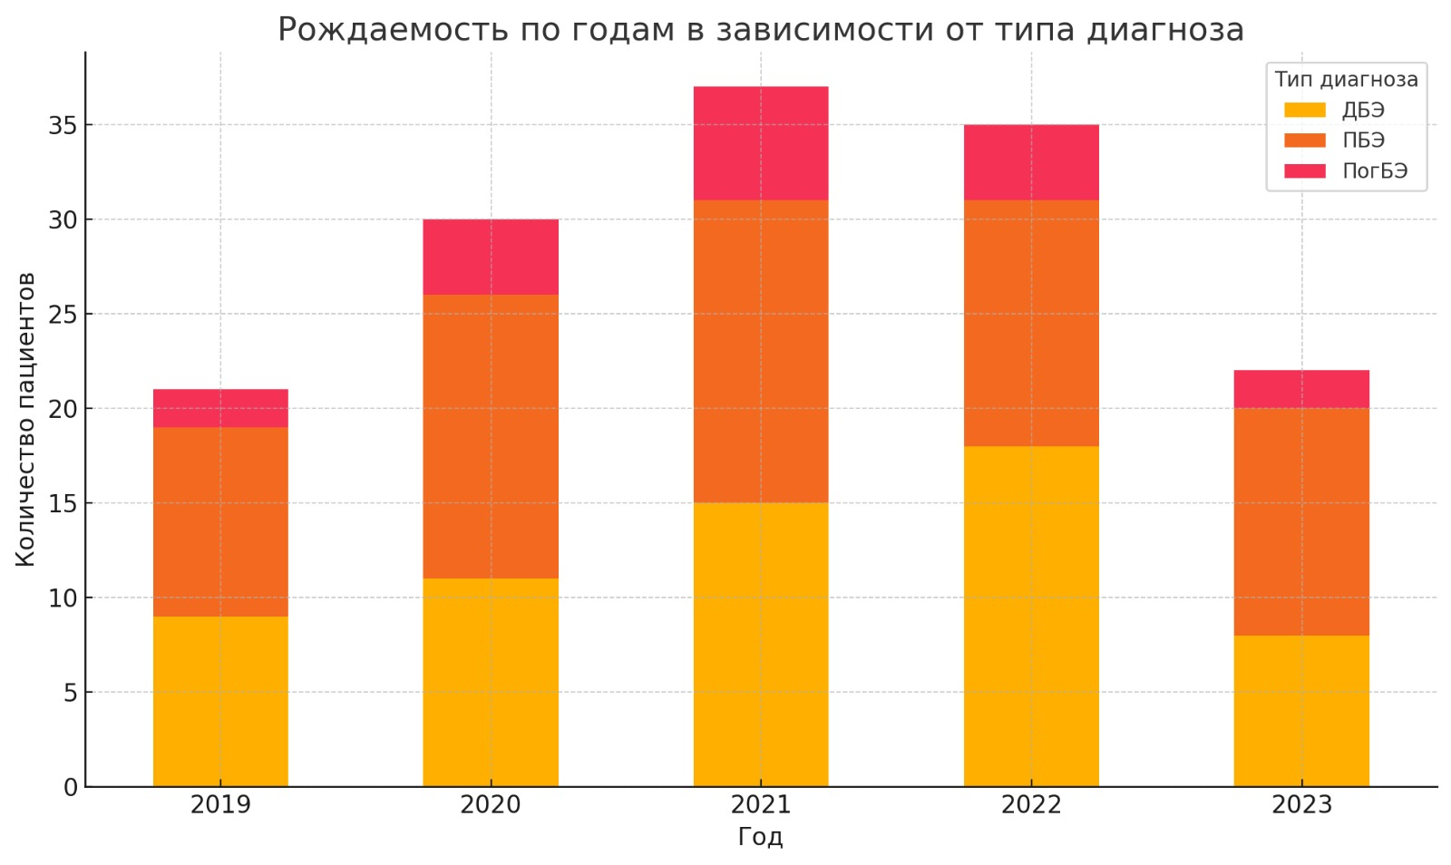

**Fig. 10.** Distribution of infants with congenital epidermolysis bullosa by diagnosis type (absolute numbers) born between 2019-2023

Number of patients / year

Diagnosis type / DEB / EBS / JEB

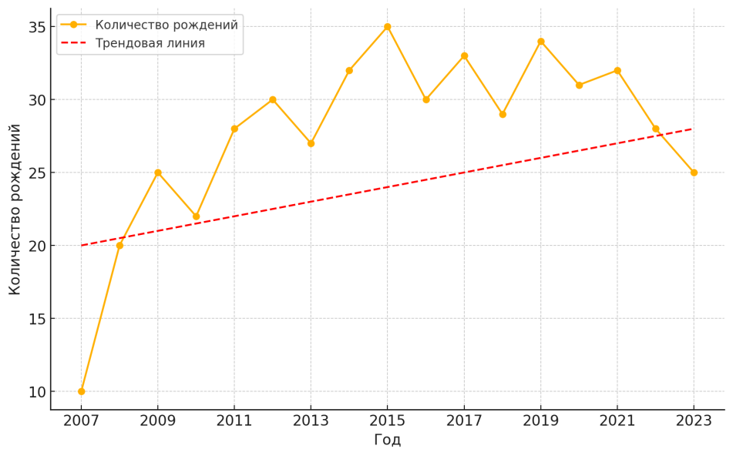

**Fig. 11.** Tendency in bird rate of children with congenital epidermolysis bullosa during the period 2007-2024

Number of births / years / number of births / trend line

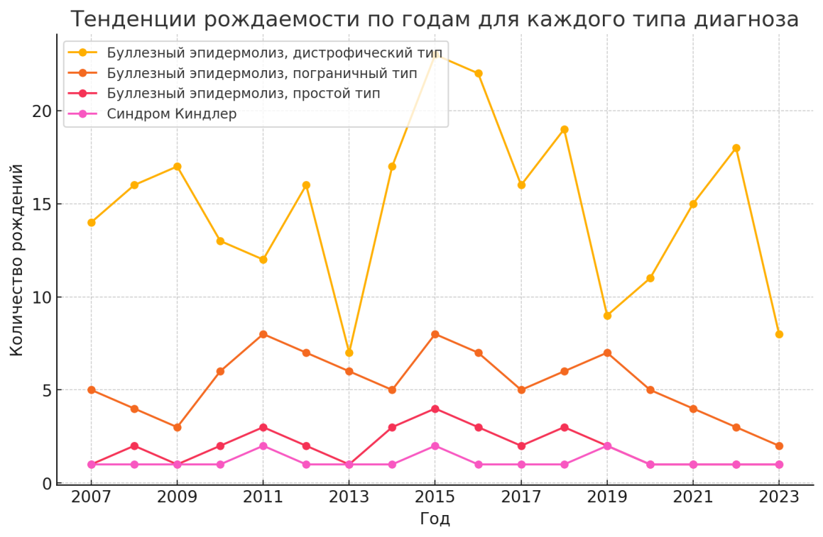



**Fig. 12.** Comparative tendency of birth rate in absolute numbers (prevalence rates) of children with congenital epidermolysis bullosa for each diagnosis type by year from 01.01.2007 to 01.01.2024

Number of births / years / Dystrophic epidermolysis bullosa / Junctional epidermolysis bullosa / Epidermolysis bullosa simplex/ Kindler syndrome

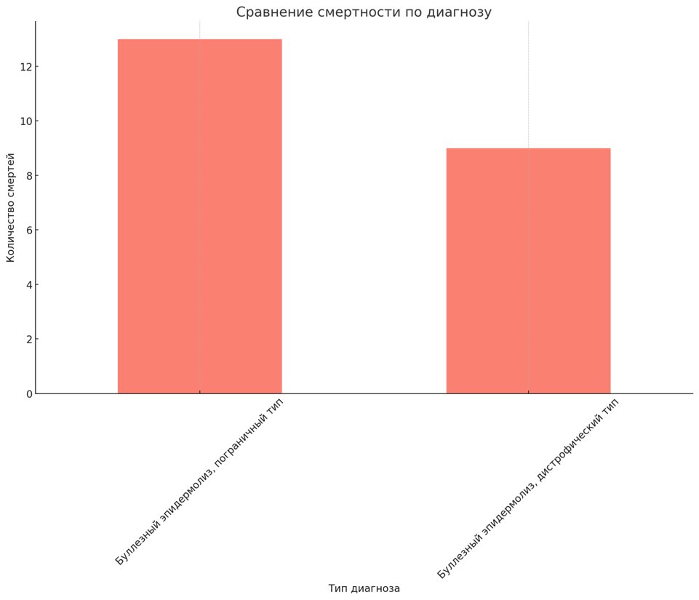

**Fig. 13.** Comparison of mortality according to the type of congenital epidermolysis bullosa

Number of fatal outcomes / comparisons of fatal outcomes by diagnosis / diagnosis type

Junctional epidermolysis bullosa / Dystrophic epidermolysis bullosa

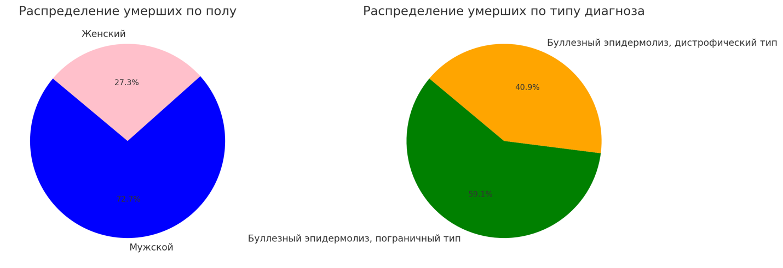

**Fig. 14.** Distribution of fatal outcomes by gender and congenital epidermolysis bullosa type

Distribution of fatal outcomes by gender

Female / male

Distribution of fatal outcomes by diagnosis type

Junctional epidermolysis bullosa / Dystrophic epidermolysis bullosa

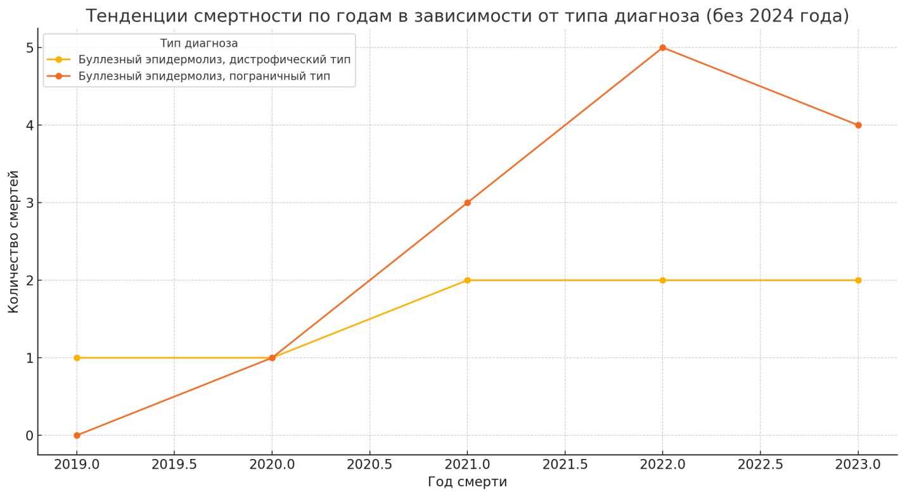

**Fig. 15.** Tendency in absolute number of fatal outcomes by year according to the diagnosis type between 01.01.2019 and 01.01.2024

Number of fatal outcomes / year of death / diagnosis type / Dystrophic epidermolysis bullosa / Junctional epidermolysis bullosa

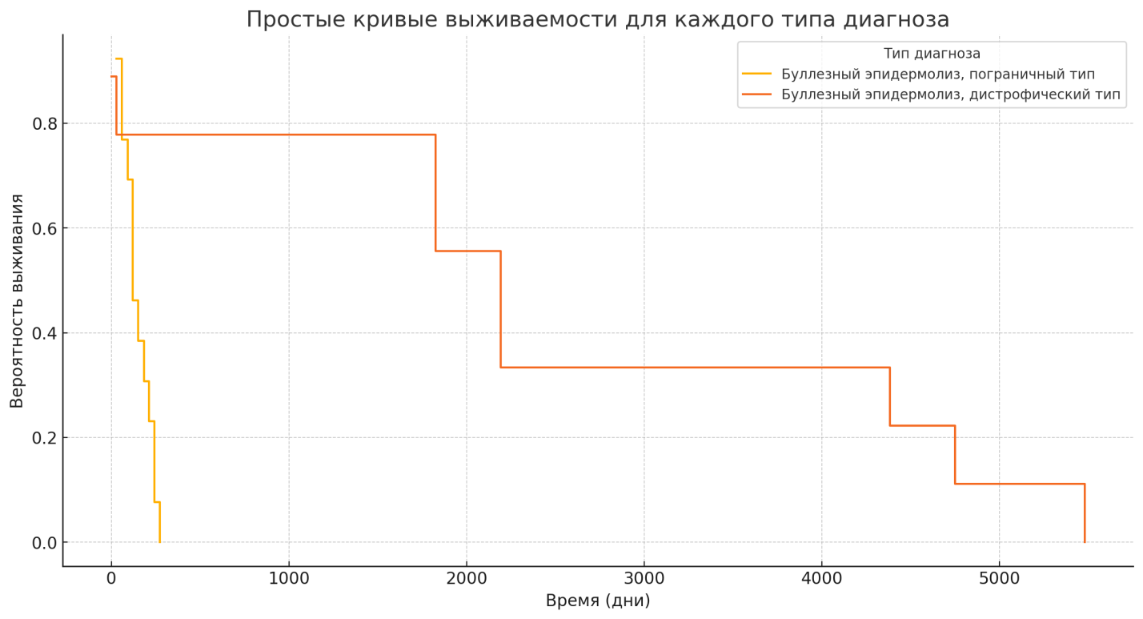

**Fig. 16.** Comparison of survival curves for dystrophic and junctional forms of congenital epidermolysis bullosa

*Note.* Curves were built via the KaplanMeierFitter tool of the lifelines library (Python programming language).

probability of survival / simple curve of survival for every diagnosis / time (days)

diagnosis type / Dystrophic epidermolysis bullosa / Junctional epidermolysis bullosa

**Table 2.** Distribution of fatal outcomes number by groups

|  |  |  |
| --- | --- | --- |
| **Cause of fatal outcome** | **DEB** | **JEB** |
| Pneumonia | 3 | – |
| **Multisystem organ failure** | **2** | **10** |
| Heart failure | 2 | – |
| Gastric hemorrhage | 1 | – |
| Kidney failure | 1 | – |
| Respiratory failure | – | 3 |

*Note.* DEB (ДБЭ) — dystrophic epidermolysis bullosa; JEB (ПгрБЭ) — junctional epidermolysis bullosa.

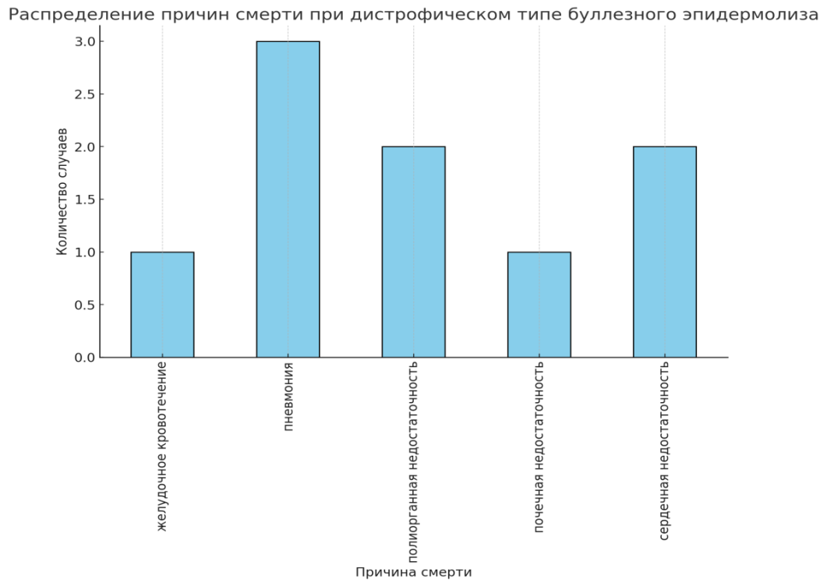

**Fig. 17.** Causes of death in congenital dystrophic epidermolysis bullosa

Number of cases / causes of death / distribution of causes of death in congenital dystrophic epidermolysis bullosa

Gastric hemorrhage / Pneumonia / Multisystem organ failure / Kidney failure / Heart failure

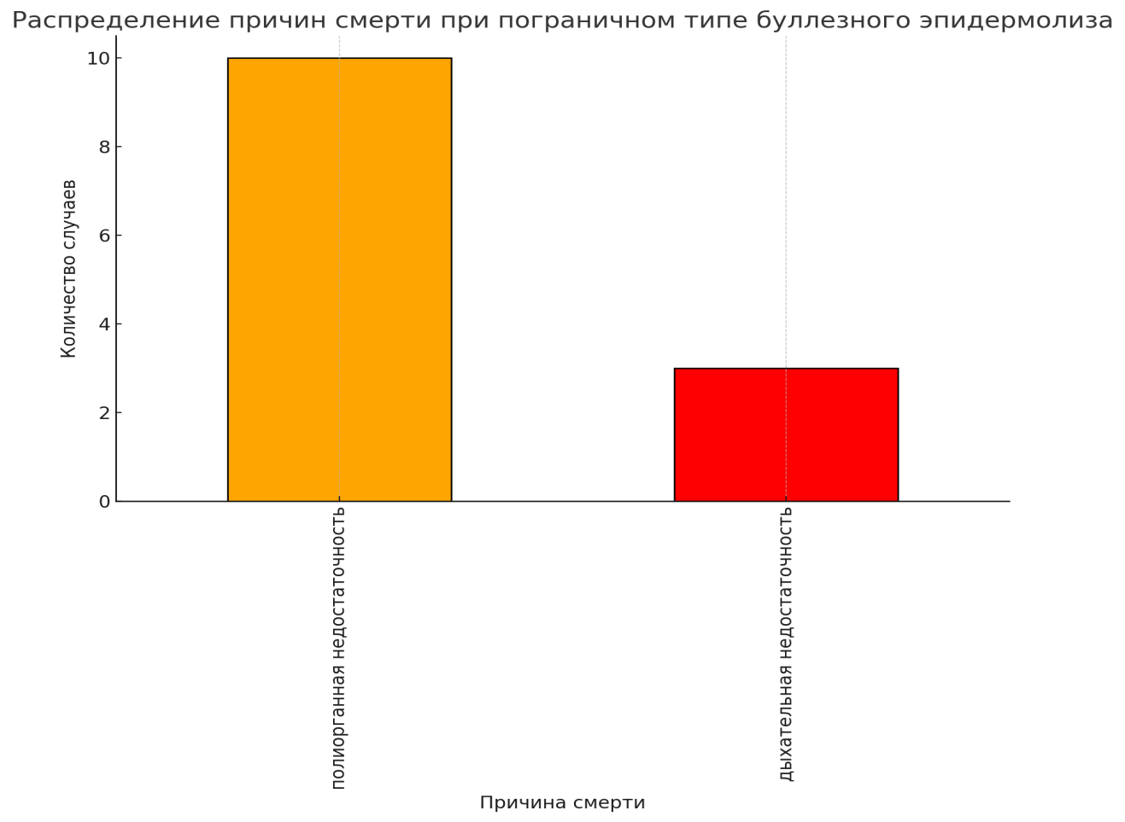

**Fig. 18.** Causes of death in congenital junctional epidermolysis bullosa

Number of cases / causes of death / distribution of causes of death in congenital junctional epidermolysis bullosa

Multisystem organ failure / Respiratory failure

**Table 3.** Prevalence rates of pediatric population with congenital epidermolysis bullosa in previously published Russian studies as compared with present one

|  |  |  |  |  |
| --- | --- | --- | --- | --- |
| **Study**  **Indexes** | Kubanov A.A. et al. (2015) | Kubanov A.A. et al. (2021) | Kotalevskaya Yu.Yu. et al. (2023) | **Present study**  **(2024)** |
| Children | 264 people | 292 | 417 | 491 |
| CEB simplex | – | 162 | 124 | 191 |
| Junctional CEB | – | – | 21 | 31 |
| Dystrophic CEB | – | 97 | 237 | 261 |
| Kindler syndrome | – | – | 7 | 8 |
| CEB, not specified | – | 14 | 13 | – |
| Other CEB | – | 5 | – | – |
| CEB without specifying its type | – | 14 | – | – |
| Number of regions included in the study | 60 regions | 68 regions | 75 regions | 76 regions |

**RESEARCH LIMITATIONS**

The analysis was conducted on a cohort of already deceased patients as median survival could not be achieved in the entire sample of patients from 0 to 17 years and 11 months. The sample limit concerned exclusively pediatric patients, so true survival for patients with CEB is reduced.

**FINANCING SOURCE**

Not declared.

**DISCLOSURE OF INTEREST**

**Nikolay N. Murashkin** — receiving research grants from pharmaceutical companies Jansen, Eli Lilly, Novartis, AbbVie, Pfizer, Amryt Pharma plc. Receiving fees for scientific counseling from companies Galderma, L’Oreal, NAOS, Pierre Fabre, Bayer, LEO Pharma, Pfizer, Sanofi, Novartis, AbbVie, Glenmark, Janssen, Invar, Librederm, Viatris, JGL, B.Braun, Swixx BioPharma.

**Roman V. Epishev** — receiving research grants from pharmaceutical companies Eli Lilly,

Novartis, AbbVie, Pfizer, Amryt Pharma plc, Jansen, Pfizer, Celgene. Receiving fees for scientific counseling from company Mölnlycke Health Care AB.

Other authors confirmed the absence of a reportable conflict of interests.

**AUTHORS CONTRIBUTION**

**Nikolay N. Murashkin** — significant contribution to the study concept and design, manuscript idea, problem formalization, material selection, work with databases, significant (crucial) manuscript revision to increase its scientific value, approval of manuscript final version.

**Roman V. Epishev** — significant contribution to manuscript writing, data collection and analysis, interpretation of results, manuscript editing, approval of manuscript final version.

**Olga S. Orlova** — significant contribution to manuscript writing, data collection and analysis, interpretation of results, material collection, manuscript writing, manuscript editing, approval of manuscript final version.

All authors have approved manuscript final version before publication, agreed to be responsible for all aspects of the work, implying proper study and resolution of any issues related to manuscript accuracy or academic integrity.