Evgeniya G. Kotova¹, Elena K. Papanova²

¹ Ministry of Health of the Russian Federation, Moscow, Russian Federation
² Russian Research Institute of Health, Moscow, Russian Federation

Operational Monitoring of Infant Mortality Based on Primary Data Analysis from the Uniform State Health Information System

Contact information:
Papanova Elena Konstantinovna, candidate of sociological sciences, head of the demographic analysis and reproductive health department in the Russian Research Institute of Health
Address: 127254, Moscow, Dobrolyubov st. 11, e-mail: e.papanova@mednet.ru
Received: 13.01.2026, accepted for publication: 16.04.2026

Background. It is crucial to provide organizational decision-making process with relevant data to manage maternal and child health service. The Ministry of Health of Russian Federation has developed a system of weekly analytical reports on infant mortality based on primary data from information systems, including distribution by regions, causes of death, dynamic series, and integral estimates. This monitoring results are the basis for implementation of management decisions to improve medical care organization in the field of maternal and child health and for evaluation of decisions efficacy. Objective. The aim of the study is to develop a model for analyzing infant mortality to manage the work of obstetric, gynecological, and pediatric services, leveling the impact of family disadvantages and social risks according to primary data. Methods. Data source on registered deaths under the age of 1 year was the Federal Register of Medical Death Records of the Uniform State Health Information System (FRMDR USHIS). Data on the number of live births from the Federal Register of Medical Birth Records (FRMBR USHIS) were also used to calculate the infant mortality rate. Results. The results of weekly operational data processing from FRMDR USHIS and FRMBR USHIS correlate with operational data on infant mortality published by Rosstat. The suggested approach allows rapidly analyse infant mortality rates at the regional level, including causes and place of death. Conclusion Existing information systems and proven approaches for primary data analysis on birth and death make it possible to increase the efficacy of obstetric, gynecological, and pediatric services management, whereas, indicators and their calculation frequency can be adapted to health organizers requests.
Keywords: infant mortality, healthcare management, primary data, causes of death, number of births
For citation: Kotova Evgeniya G., Papanova Elena K. Operational Monitoring of Infant Mortality Based on Primary Data Analysis from the Uniform State Health Information System. Voprosy sovremennoi pediatrii — Current Pediatrics. 2026;25(2):50-66. (In Russ). doi: https://doi.org/10.15690/vsp.v25i2.3011

Fig. 1. Infant mortality rate by regions of Russian Federation according to the FRMDR USHIS (with the 95% confidence interval) and Rosstat data, per 1000 live births, January — December 2025

Table. Infant mortality by main classes of causes of death in 2023 according to Rosstat and the FRMDR USHIS
Infant mortality | Rosstat | FRMDR
Total deaths, from all causes of death | 100 | 100
Including from:  - certain conditions originating in the perinatal period, % | 46,4 | 43,8
- congenital anomalies (malformations), % | 20,5 | 19,0
- respiratory diseases, % | 6,0 | 5,2
- certain infectious and parasitic diseases, % | 4,8 | 3,4
- external causes, % | 6,5 | 4,7
- diseases of the digestive system, % | 0,8 | 0,9
- novel coronavirus infection (COVID-19), % | 0,4 | 0,2
- others, % | 14,7 | 22,9

Fig. 2. Infant mortality rate by regions of Russian Federation in January — December 2025, calculations based on data from FRMDR USHIS and FRMBR USHIS
No data
21 regions / 21 regions / 21 regions / 22 regions

Fig. 3. Widget example. Infant mortality by regions of Russian Federation (January — December 18, 2025)
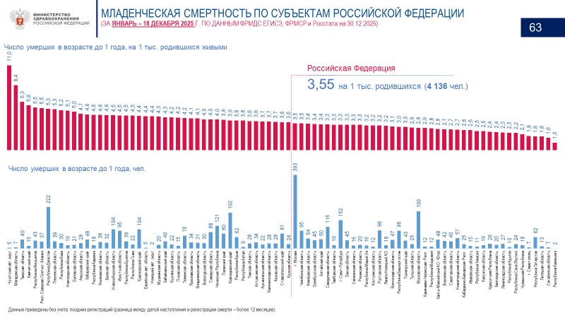

Fig. 4. Widget example. Changes in infant mortality by regions of Russian Federation from January to December 18, 2025, compared to the same period in 2024, according to FRMDR USHIS data as of December 30, 2025
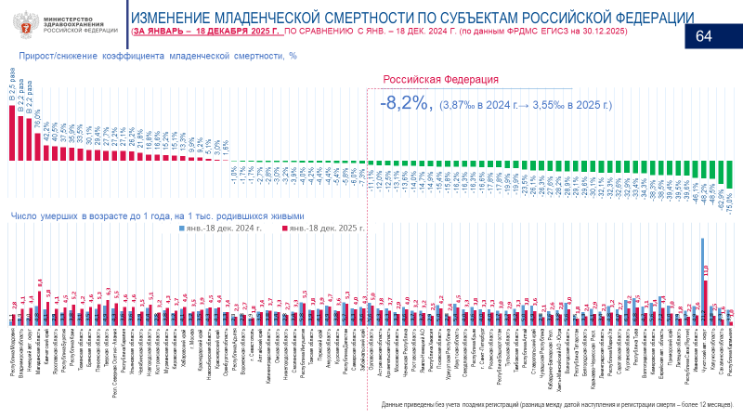

Fig. 5. Widget example. Changes in the number of deaths under 1 year of age by region of Russian Federation from January to December 18, 2025, compared to the same period in 2024, according to FRMDR USHIS data as of December 26, 2025
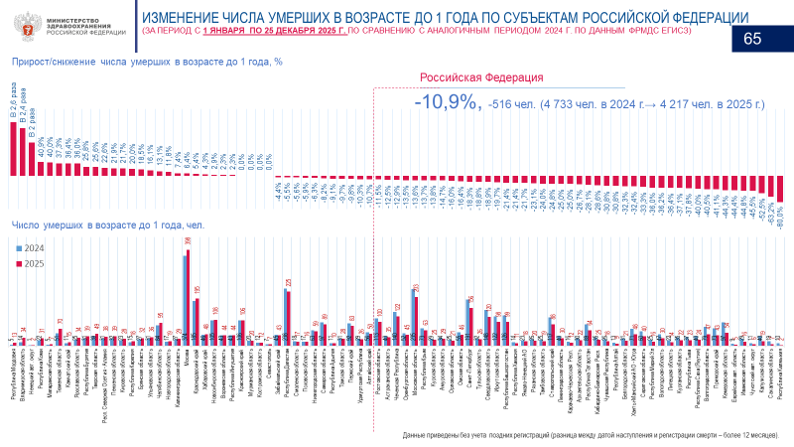

Fig. 6. Widget example. Number of deaths under 1 year of age by place of death by regions of Russian Federation from January to December 18, 2025, compared to the same period in 2024, according to FRMDR USHIS data as of December 26, 2025
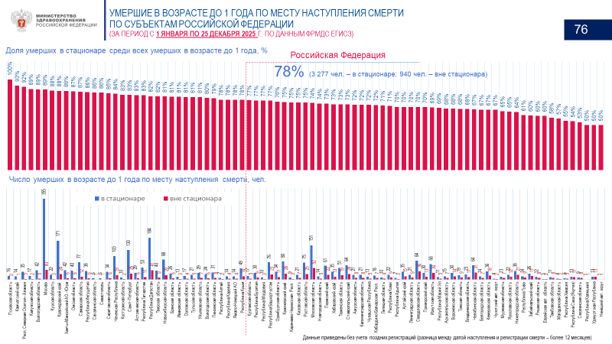

Fig. 7. Widget example. Changes in the number of deaths under 1 year of age by main causes of death (from January 1 to December 25, 2025, compared to the same period in 2023–2024, according to FRMDR USHIS data)
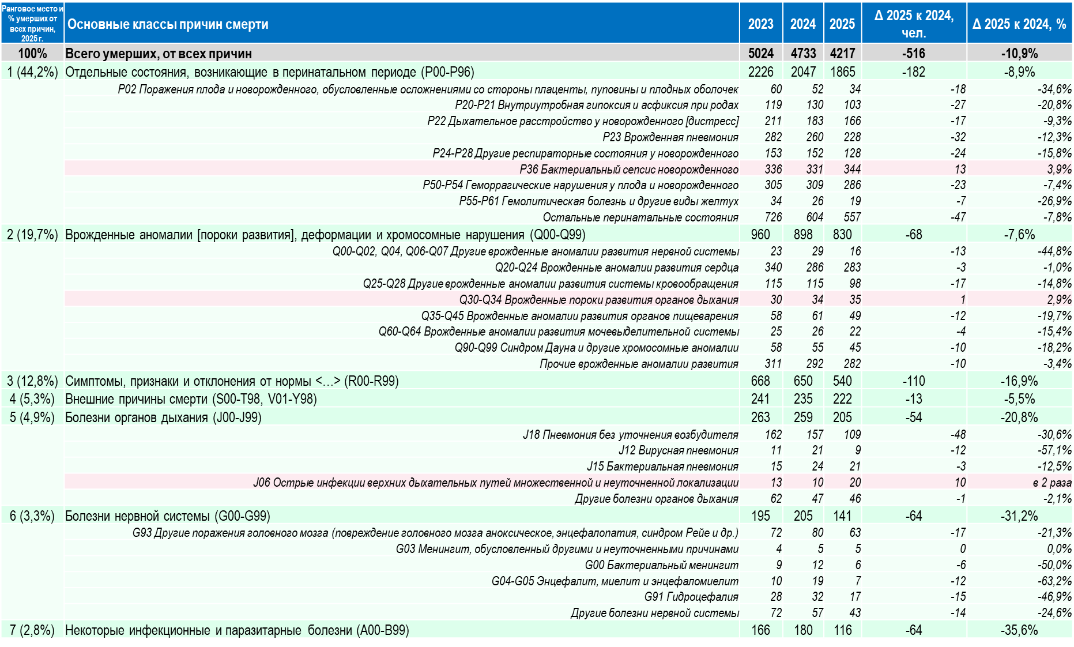

Fig. 8. Widget example. Changes in the number of deaths under 1 year of age from external causes of death (from January 1 to December 25, 2025, compared to the same period in 2023–2024, according to FRMDR USHIS data)

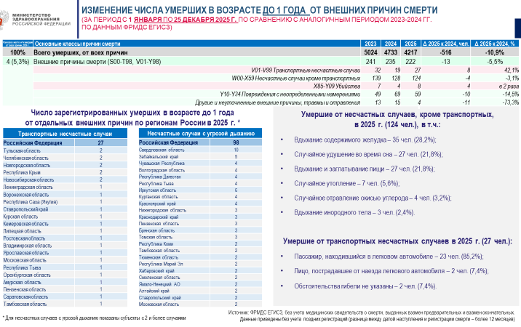

Fig. 9. Widget example. Changes in the number of deaths under 1 year of age from certain infectious and parasitic diseases (from January 1 to December 25, 2025, compared to the same period in 2023–2024, according to FRMDR USHIS data)

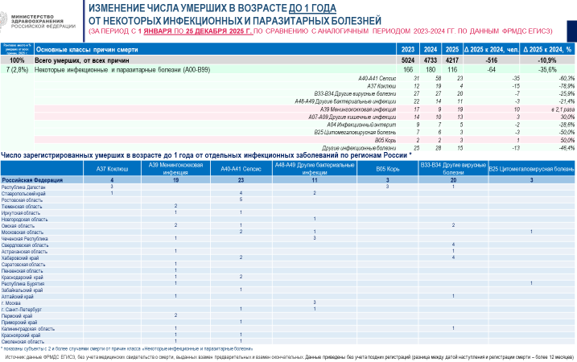

Fig. 10. Widget example. Number of deaths under 1 year of age from certain conditions originating in the perinatal period by regions of Russian Federation from January to December 18, 2025, compared to the same period in 2024, according to FRMDR USHIS data as of December 30, 2025

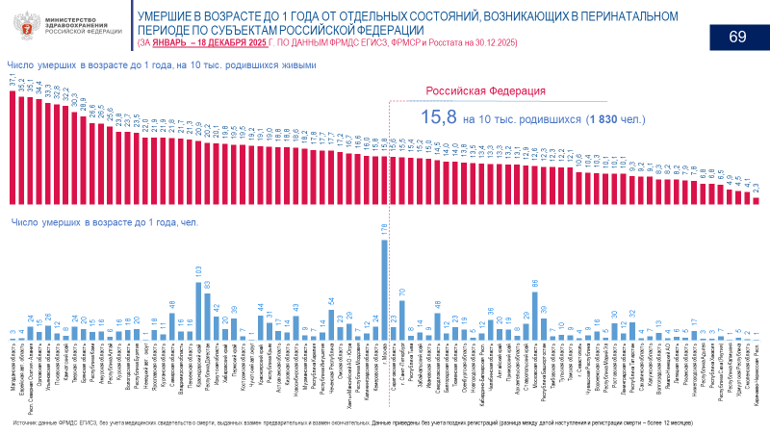

Fig. 11. Distribution of registered deaths under 1 year of age in Saint Petersburg from congenital anomalies by place of residence, medical organization, and causes of death for the period from January 1 to November 27, 2025, according to FRMDR USHIS data

RESEARCH LIMITATIONS
- There may be discrepancies between infant mortality rate and Rosstat data for specific dates of uploading from information systems in certain subjects of Russian Federation. It can be associated with technical errors in the data transmission process. Other discrepancies may be observed between uploading at a specific date and time in some regions with a small number of births and deaths under the age of 1 year. Moreover, data correction can be implemented via additional uploads, errors elimination, and additional uploading of data to information systems by the technical support service.
- 2. Current version of operational weekly monitoring throughout the year may contain up to 20% preliminary medical death certificates, where cause of death can subsequently be specified according to the order of the Ministry of Health of Russian Federation dated April 15, 2021 №352n "On approval of accounting forms for medical documentation, certifying cases of death, and the procedure for their issuance" [10] by issuing medical certificates instead of preliminary and instead of final ones. This should considered during operational analysis of infant mortality by cause of death, especially in cases where the cause of death in preliminary certificates was not established before laboratory and other results (ICD-10 — R99).

FINANCING SOURCE
Not specified.

DISCLOSURE OF INTEREST
Not declared.

AUTHORS’ CONTRIBUTIONS
Evgeniya G. Kotova — study management, concept definition, data analysis, methodology development, validation, manuscript review and editing.
Elena K. Papanova — data processing, data analysis, methodology development, validation, visualization, manuscript draft writing, manuscript review and editing.

