Ilya A. Trembach^{1, 2}, Elizaveta S. Khatit²

¹ Children's Regional Clinical Hospital, Krasnodar, Russian Federation
² Kuban State Medical University, Krasnodar, Russian Federation

Breath-Holding Test after Deep Inhalation as a Risk Predictor of Adverse Events after Elective Abdominal Surgery in Children: Prospective Cohort Study

Contact information:
Trembach Ilya Antonovich, anesthesiologist of the Children's Regional Clinical Hospital, teaching assistant at anesthesiology, resuscitation and transfusiology department of the Kuban State Medical University
Адрес: 350007, Krasnodar, Victory sq., 1, e-mail: trembachilya@gmail.com
Article received: 01.10.2025, accepted for publication: 16.06.2026

Background. Early postoperative adverse events in children remain a significant clinical problem, their prognosis via multifactorial scales has several limitations (complexity, subjective assessment, insufficient accuracy). Thus, the search for accurate and non-invasive methods for assessing risk of postoperative events remains relevant. Objective. The aim of the study is to examine the prognostic value of breath-holding test (BHT) duration after deep inhalation in assessing the risk of adverse events after elective abdominal surgery in children. Methods. The single-center prospective cohort study included children aged 5-10 years with ASA I-II physical status and planned abdominal surgery. All participants were measured BHT duration (in seconds) three times after deep inhalation with calculating the mean value (at the preoperative stage — the day before anesthesia). Any adverse postoperative events were recorded during the first 6 hours after surgery: pain, postoperative nausea and vomiting, shivering, and agitation. The predictive BHT efficacy was analyzed via multivariate logistic regression and k-fold cross-validation. Results. The study included 160 children. Adverse postoperative events were reported in 36 (22.5%) cases. BHT duration after deep inhalation was the only statistically significant predictor of adverse events in the multivariate logistic regression model: AUC — 0.833 (95% confidence interval (CI) 0.781-0.894), odds ratio — 0.82 (95% CI 0.77-0.88). BHT duration did not change significantly during cross-validation of predictive performance metrics. The optimal value for the development of adverse postoperative events prognosis was BHT duration ≤ 28 seconds. The frequency of adverse postoperative events in children with high postoperative risk (BHT ≤ 28 seconds) was more than twice as much as in children with BHT > 28 seconds (16.3 and 6.2%, respectively; p <0.001). Conclusion. BHT test after deep inhalation is a simple and non-invasive method to stratify risk while planning abdominal surgery in children. The BHT duration ≤ 28 seconds is the independent predictor of adverse events after such surgeries.
Keywords: abdominal surgery, postoperative complications, risk assessment, prognosis, breath holding, breath-holding test, children
For citation: Trembach Ilya A., Khatit Elizaveta S. Breath-Holding Test after Deep Inhalation as a Risk Predictor of Adverse Events after Elective Abdominal Surgery in Children: Prospective Cohort Study. Voprosy sovremennoi pediatrii — Current Pediatrics. 2026;25(3):154-163. doi: https://doi.org/10.15690/vsp.v25i3.3055

Table 1. Comparative characteristics of children with/without adverse postoperative events after abdominal surgery
Indicators | With adverse events (n = 36) | Without adverse events (n = 124) | р
Age, years | 6 (6; 8) | 7 (6; 8,5) | 0,014
Gender (male), n (%) | 29 (81) | 80 (65) | 0,069
Height, sm | 120 (117; 125) | 122,5 (117,5; 130) | 0,134
Weight, kg | 21,5 (18; 26) | 22 (18; 29) | 0,536
Recovery time in operating room*, min | 12 (10; 14) | 9 (7; 11) | < 0,001
Fluid and food restriction time, min | 755 (727,5; 837,5) | 790 (737,5; 877,5) | 0,337
Breath-holding test, seconds | 23,5 (18; 31,5) | 36 (32; 41) | < 0,001
Note. <*> — time to >13 points on the DPART scale (Discerning Post Anesthesia Readiness for Transition). Adverse events: postoperative pain, nausea, vomiting, shivering, and agitation (see Methods for details).

Table 2. Characteristics and quality of regression model for adverse postoperative events with single predictor — BHT duration
Metrics | Values
Logarithmic likelihood of the full model | 117,29
R² Nagelkerke | 0,4322
AUC (95% CI) | 0,833 (0,781–0,894)
Coefficient (β) | −0,20043
Standard error (SE) | 0,03423
p-value | < 0,0001
Odds ratio (95% CI) | 0,82 (0,77–0,88)
Sensitivity, n/N (%) | 25/36 (69)
Specificity, n/N (%) | 119/124 (96)
Note. AUC — area under ROC-curve; CI (ДИ) — confidence interval.

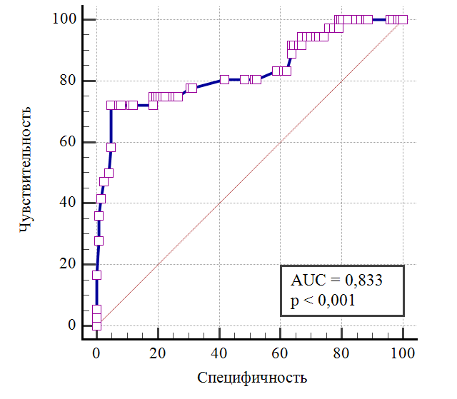
Sensitivity / Specificity
Fig. Ppredictive significance of breath-holding test duration after deep inhalation in risk assessment of postoperative complications in children after abdominal surgery
Note. Postoperative complications included postoperative pain, nausea, vomiting, shivering, and/or agitation (see Methods for criteria).

Table 3. Adverse postoperative events in children after abdominal surgery with different BHT duration after deep inhalation
Indicators | Risk groups |  | p
Indicators | High (≤ 28 seconds), n = 40 | Low (> 28 seconds), n = 120 | p
All complications, n (%) | 26 (16) | 10 (6,2) | < 0,001
Pain, n (%) | 24 (15) | 9 (5,6) | < 0,001
Nausea and/or vomiting, n (%) | 8 (5) | 0 | < 0,001
Shivering, n (%) | 2 (1) | 1 (0,6) | 0,154
Agitation, n (%) | 5 (3) | 0 | < 0,001
Note. Risk groups are determined via threshold value of BHT duration and Youden index (sum of sensitivity and specificity minus 1).

Table 4. Results of k-fold cross-validation for final prognostic model with single predictor — BHT duration
Indicator | Values
AUC (95% CI) | 0,839 (0,773–0,904)
Median probability (Q₁; Q₃) | 0,483 (0,458; 0,506)
Ppositive predictive value | 0,818
Accuracy | 0,875
Sensitivity, % | 61,1
Specificity, % | 95,1
F1-measure | 0,686
Brier score | 0,107
Note. AUC — area under ROC-curve; CI (ДИ) — confidence interval.

Research limitations
This study has several limitations. Firstly, the study was conducted in one institution with participation of children aged 5-10 years, which limits results generalizability. Results expansion for risk assessment of adverse events after other (non-abdominal) surgeries is also limited. Secondly, limited number of potential predictors were included in the analysis, which does not allow to fully assess the independent prognostic significance of BHT after deep inhalation. Third, there was no comparison of BHT predictive efficacy with existing prognostic scales and perioperative risk models. Fourth, there is no external validation on independent samples of prognostic model based on BHT results. Fifth, absence of retrospective database of operated children with BHT results limits the ability to assess stability and generalizability of proposed prognostic model. Finally, the choice of analyzed postoperative events (justified by clinical significance) does not cover the full range of possible adverse postoperative complications.

ACKNOWLEDGEMENTS
The authors express gratitude to Nikita Vladimirovich Trembach, doctor of medicine, associate professor of anesthesiology, resuscitation and transfusiology department of the Kuban State Medical University, for his valuable comments at study planning and discussing the results.

FINANCING SOURCE
Not specified.

DISCLOSURE OF INTEREST
Not declared.

AUTHORS’ CONTRIBUTION
Ilya A. Trembach — study concept, data processing, conducting the study, methodology development, study assurance, study management, manuscript review and editing.
Elizaveta S. Khatit — data analysis, validation, visualization, manuscript draft writing.

Supplements
Supplement 1. Wong — Baker faces pain rating scale [21]
Note. This scale is designed for subjective of pain in children. The patient is asked to choose the face image that most accurately reflects experienced pain. The score varies from 0 to 5 points, where 0 corresponds to the absence of pain, and 5 — to the most significant (unbearable) pain.

Supplement 2. Visual analogue pain scale [22]
Note. This scale is a horizontal line 10 cm long; one end (on the left) marked with "no pain," and the other — "unbearable pain". The patient is asked to mark on the line a point corresponding to the severity of experienced pain.

Supplement 3. Postanaesthetic Shivering Scale by Crossley and Mahajan [24]
Note. This scale is used to evaluate postoperative shivering severity according to clinical observation of the patient. Authors have translated the scale. There is no validated Russian version.

Supplement 4. Pediatric Anesthesia Emergence Delirium Scale (PAED) [25]
Note. This scale is designed to evaluate postoperative agitation (emergence delirium) severity in children according to observation of patient behavior. The total score is calculated as the sum of all points and can range from 0 to 20. Higher values correspond to greater agitation severity. Authors have translated the scale. There is no validated Russian version.

Supplement 5. Discerning Post Anesthesia Readiness for Transition (DPART) [29]
Note. This scale is designed to evaluate patient's readiness to transfer from the postoperative room to the next treatment stage. Authors have translated the scale. There is no validated Russian version according to our data. The translation was performed without formal cultural adaptation procedure and psychometric validation; results interpretation should be performed with caution. It is necessary to fullfill paragraphs 1-13 to transfer patient to the next treatment stage (from the operating room to the ward). BP (АД) — blood pressure; CBV (ОЦК) — circulating blood volume.

