Anna V. Makarova¹, Andrey A. Pershin¹, Nikita O. Khusainov¹, Оlga S. Maslak^{1, 2}, Аlexandr Yu. Mushkin^{1, 3}

¹ Saint Petersburg Research Institute of Phthisiopulmonology, Saint Petersburg, Russian Federation
² Saint Petersburg State University, Saint Petersburg, Russian Federation
³ First Saint Petersburg State Medical University named after Academician I.P. Pavlov, Saint Petersburg, Russian Federation

Changes in Lung Volume and Pulmonary Ventilation in Adolescents with Idiopathic and Neuromuscular Scoliosis after Surgical Correction of Spinal Deformity: Retrospective Cohort Study

Contact information:
Makarova Anna Valeryevna, pediatrician in the clinic of pediatric surgery and orthopedics at Saint Petersburg Research Institute of Phthisiopulmonology
Address: 190961, Saint Petersburg, Ligovskiy avenue, 2–4, тел.: +7 (911) 133-38-80, e-mail: makarova_a09@mail.ru
Recieved: 29.01.2026, accepted for publication: 16.06.2026

Background. Neuromuscular scoliosis (NMS) is the most challenging form of the disease to correct. Unlike idiopathic scoliosis (IS), in NMS, skeletal deformity is accompanied by primary weakness of the intercostal muscles and diaphragm, impaired cough clearance, and a tendency toward hypoventilation. The outcomes of surgical correction of IS and NMS in age- and deformity severity-matched patient groups have not been previously studied. Objective. The aim of the study is to compare changes in volumetric and density characteristics of lung tissue in adolescents with IS and NMS after surgical correction. Methods. This study included data from patients aged 13–17 years with IS and NMS who underwent posterior spinal instrumentation due to thoracic/thoracolumbar scoliosis >40° between 2021 and 2024. The primary endpoint was the change in total lung volume (mL). Secondary endpoint included changes in right and left lung volumes (mL), as well as the proportion of density-defined lung parenchymal zones (% of normoventilated, hypoventilated, and atelectatic zones). Lung volume and pulmonary ventilation were assessed via CT volumetry before (no earlier than 2 months prior) and after surgery (no earlier than 2 weeks and no later than 3 months after the procedure). Results. The outcomes of surgical correction of spinal deformity were studied in 30 patients with IS and 32 patients with NMS matched in gender, age, and degree of spinal deformity (Cobb angle). Baseline total lung volume in the NMS group was lower than in the IS group, with median values of 1084 (639; 1547) and 2041 (1580; 2509) mL, respectively (p<0.001). After surgery, patients with NMS showed an increase in total lung volume of 110 mL (95% confidence interval [CI] 28 to 192, p=0.002), whereas the IS group showed a decrease of 266 mL (95% CI –490 to –42; p=0.012). At the same time, the proportion of normoventilated lung zones increased (right lung by 16.5%, left lung by 15.6%; p<0.001) in patients with NMS, while the proportion of hypoventilated zones decreased (right lung by 15.0%, left lung by 9.3%; p<0.001), as did the proportion of atelectatic zones (right lung by 4.8%, left lung by 6.9%; p<0.001). In the IS group, no significant changes in the distribution of lung density zones were observed, except for a decrease in the proportion of left-sided atelectasis from 5.1% to 2.3% (p=0.044). Conclusion. Surgical correction of scoliosis leads to different dynamics of lung volumetric and density characteristics in adolescents with NMS and IS. There is an increase in total lung volume, an increase in the proportion of normoventilated zones, and a decrease in hypoventilated and atelectatic zones in NMS group, while in IS group there is a decrease in total lung volume and atelectatic zones without changes in other pulmonary ventilation parameters. The main limitations of the study are its retrospective design and the analysis of lung volumetric and density characteristics dynamics in early postoperative period.
Keywords: neuromuscular scoliosis, idiopathic scoliosis, surgical correction, computed tomography, lung volumetry, adolescents
For citation: Makarova Anna V., Pershin Andrey A., Khusainov Nikita O., Maslak Оlga S., Mushkin Аlexandr Yu. Changes in Lung Volume and Pulmonary Ventilation in Adolescents with Idiopathic and Neuromuscular Scoliosis after Surgical Correction of Spinal Deformity: Retrospective Cohort Study. Voprosy sovremennoi pediatrii — Current Pediatrics. 2026;25(3):164-172. doi: https://doi.org/10.15690/vsp.v25i3.3058

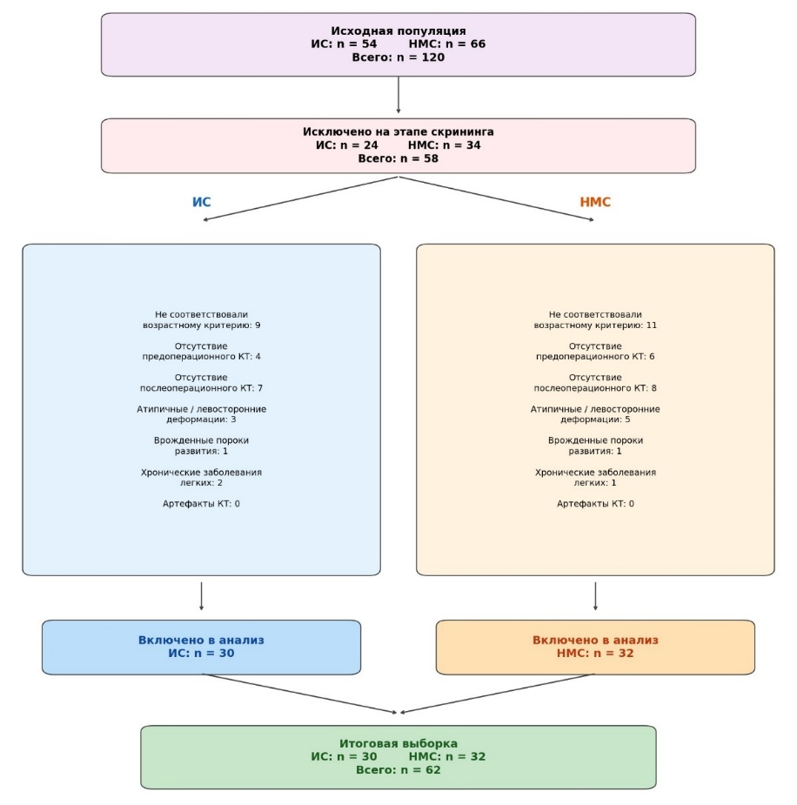
Fig. 1. Stages of study sampling
Note. IS — idiopathic scoliosis; NMS — neuromuscular scoliosis; CT — computed tomography.

Table 1. Baseline characteristics of patients with IS and NMS
Indicator | IS (n = 30) | NMS (n = 32) | Effect size | p
Age, years | 15,2 (14,2; 16,1) | 14,8 (13,9; 15,9) | d = 0,18 | 0,319
Gender (female), n (%) | 24 (80,0 %) | 22 (68,8 %) | h = 0,25 | 0,312
BMI, kg/m² | 18,2 (17,0; 20,1) | 17,0 (15,8; 18,5) | d = 0,48 | 0,065
Main curve type, n (%):  - right-sided thoracic  - right-sided thoracolumbar | 18 (60,0%)  12 (40,0%) | 22 (68,8%)  10 (31,2%) | h = 0,18 | 0,456
Note. Quantitative data is presented as median (Q1; Q3). Effect size for quantitative variables is expressed as Cohen's d, and for categorical variables as Cohen's h (small effect — approximately 0.2, medium — 0.5, large — 0.8).

Table 2. Changes in total lung volume after surgical correction of IS and NMS in adolescents
Group | Before surgery, ml | After surgery, ml | Δ, ml | Difference Δ (95% CI), ml | p
IS (n=30) | 2041 (1580; 2509) | 1775 (1410; 2139) | –266 (–622; +18) | –376 (–562; –190) | < 0,001
NMS (n=32) | 1084 (639; 1547) | 1194 (810; 1726) | +110 (–123; +343) | –376 (–562; –190) | < 0,001
Note. Descriptive statistics for baseline data, postoperative data, and changes in the parameters are presented as median (Q1; Q3). Δ — difference (postoperative minus preoperative). The difference in Δ between groups is presented as the median difference (IS minus NMS) with 95% CI calculated via the Hodges–Lehmann method; p-values were calculated via the Mann–Whitney U test. IS — idiopathic scoliosis; NMS — neuromuscular scoliosis.

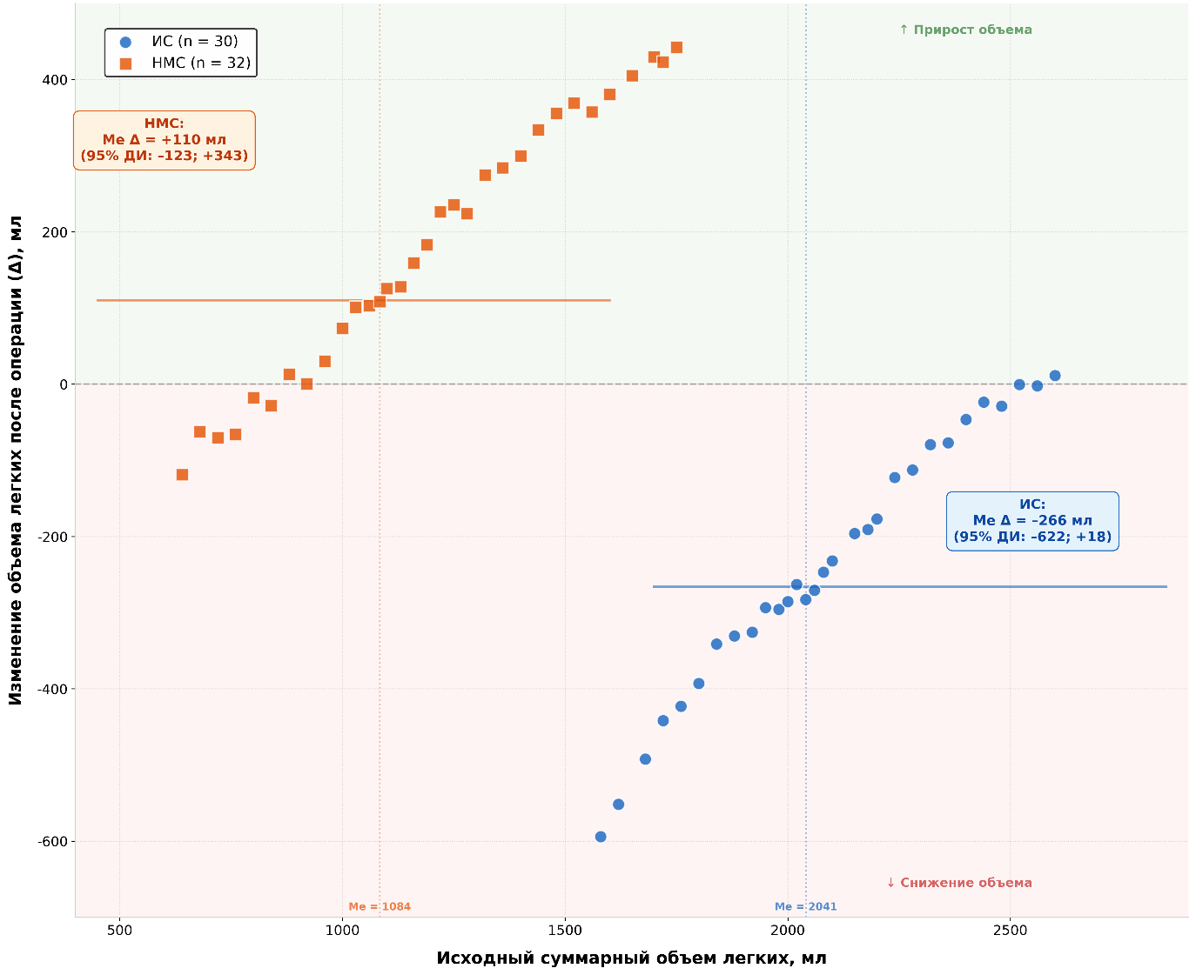
Fig. 2. Correlation between baseline total lung volume and its change (Δ) after surgical correction in adolescents with IS and NMS
Note. Horizontal axis — baseline total lung volume (mL); vertical axis — postoperative change in lung volume (Δ, mL). Horizontal solid lines represent median Δ values in each group. Vertical dashed lines represent median baseline volumes. Effect size Cohen's d = 1.02 (large effect). Δ — difference (postoperative minus preoperative). Me — median; CI — confidence interval; IS — idiopathic scoliosis; NMS — neuromuscular scoliosis.

Table 3. Dynamics of right and left lung volumes (mL) after surgical correction of IS and NMS in adolescents
Indicator | Group | Before surgery | After surgery | Δ, ml | Difference Δ (95 % CI), ml | p | d
Right lung | IS | 1031 (787; 1275) | 941 (743; 1139) | –90 (–288; +52) | –115 (–236; +3) | 0,012 | 0,63
Right lung | NMS | 591 (343; 807) | 616 (411; 900) | +25 (–98; +147) | –115 (–236; +3) | 0,012 | 0,63
Left lung | IS | 1011 (788; 1234) | 834 (667; 1000) | –177 (–334; –20) | –262 (–410; –115) | < 0,001 | 0,98
Left lung | NMS | 493 (296; 740) | 578 (399; 826) | +85 (–22; +192) | –262 (–410; –115) | < 0,001 | 0,98
Note. Indicators are presented as median (Q1; Q3). Δ — difference (postoperative minus preoperative). The difference in Δ between groups is presented as the median difference (IS minus NMS) with 95% CI calculated via the Hodges–Lehmann method; p-value was calculated via the Mann–Whitney U test; Cohen's d was calculated via arithmetic means and standard deviations. IS — idiopathic scoliosis; NMS — neuromuscular scoliosis.

Table 4. Changes (Δ) in density-defined zones of lung parenchyma after surgery in adolescents with IS (n=30) and NMS (n=32)
Zone | Lung | Group | Before surgery, % | After surgery, % | Δ, % | Difference Δ (95% CI), % | p | Cohen’s d
Normoventilation | Right | IS | 86,1 (75,9;94,0) | 84,6 (71,2;93,0) | –0,2 (–5,4; +3,9) | –16,5 (–25,1; –8,0) | < 0,001 | 1,18
Normoventilation | Right | NMS | 45,8 (19,3;72,3) | 62,3 (39,2;85,4) | +16,5 (8,0; 24,9) | –16,5 (–25,1; –8,0) | < 0,001 | 1,18
Normoventilation | Left | IS | 84,8 (69,2;93,0) | 88,9 (62,1;94,8) | +1,0 (–3,2; +5,0) | –14,0 (–22,5; –5,5) | 0,002 | 1,01
Normoventilation | Left | NMS | 48,6 (23,2;74,0) | 64,2 (41,2;87,2) | +15,6 (8,0; 21,0) | –14,0 (–22,5; –5,5) | 0,002 | 1,01
Hypoventilation | Right | IS | 8,1 (3,2;16,2) | 9,1 (5,8;20,5) | +0,6 (–2,1; +3,7) | +14,0 (6,5; 21,5) | < 0,001 | 1,07
Hypoventilation | Right | NMS | 38,0 (19,0;50,0) | 22,0 (12,0;42,0) | –15,0 (–20,5; –5,0) | +14,0 (6,5; 21,5) | < 0,001 | 1,07
Hypoventilation | Left | IS | 9,4 (4,2;16,2) | 7,0 (5,0;11,8) | –0,9 (–4,0; +2,1) | +9,0 (2,8; 15,2) | 0,005 | 0,84
Hypoventilation | Left | NMS | 35,7 (16,4;55,0) | 26,0 (8,0;40,0) | –9,3 (–14,0; –3,0) | +9,0 (2,8; 15,2) | 0,005 | 0,84
Atelectasis | Right | IS | 3,5 (2,0;10,1) | 4,1 (1,5;7,5) | +0,2 (–0,8; +1,4) | +5,0 (2,1; 7,9) | 0,001 | 0,92
Atelectasis | Right | NMS | 18,0 (8,5;19,0) | 11,2 (3,1;19,3) | –4,8 (–7,1; –1,5) | +5,0 (2,1; 7,9) | 0,001 | 0,92
Atelectasis | Left | IS | 5,1 (2,0;12,0) | 2,3 (0,4;5,4) | –1,4 (–3,6; +0,1) | +5,5 (1,9; 9,1) | 0,004 | 0,88
Atelectasis | Left | NMS | 16,9 (5,6;28,2) | 10,0 (3,0;16,0) | –6,9 (–9,6; –2,4) | +5,5 (1,9; 9,1) | 0,004 | 0,88
Emphysema | Right | IS | 0,0 (0,0;0,2) | 0,2 (0,0;0,6) | +0,1 (–0,1; +0,4) | +0,1 (–0,2; +0,5) | 0,68 | 0,46
Emphysema | Right | NMS | 0,0 (0,0;0,1) | 0,0 (0,0;0,0) | 0,0 (–0,1; +0,1) | +0,1 (–0,2; +0,5) | 0,68 | 0,46
Emphysema | Left | IS | 0,0 (0,0;0,2) | 0,1 (0,0;0,2) | 0,0 (–0,1; +0,2) | 0,0 (–0,2; +0,3) | 0,81 | 0,06
Emphysema | Left | NMS | 0,0 (0,0;0,2) | 0,0 (0,0;0,2)
Note. Indicators are presented as median (Q1; Q3). Δ — postoperative change (postoperative minus preoperative). The difference in Δ (IS minus NMS) and 95% CI were calculated via the Hodges–Lehmann method; p-values were calculated via the Mann–Whitney U test; Cohen's d was calculated via arithmetic means and standard deviations.
.

Table 5. Scoliotic deformity and correction rate in patients with IS and NMS
Evaluated indicator | IS (n=30) | NMS (n=32) | p | Cohen’s d
Cobb angle before surgery, ° | 62,7 (50,0; 76,7) | 75,5 (56,0; 91,0) | 0,187 | 0,28
Cobb angle after surgery, ° | 18,5 (12,0; 26,0) | 22,0 (15,0; 30,0) | 0,321 | 0,21
Correction rate (Δ), % | 70,5 (65,0; 76,0) | 68,0 (60,0; 75,0) | 0,456 | 0,10
Difference Δ (95% CI), % | 2,5 (–4,5; 9,5) |  | 0,456 | –
Note. Variables description is presented with median (Q1; Q3). Δ — postoperative change (%). Intergroup comparisons were performed via the Mann–Whitney U test. The difference in Δ (IS minus NMS) and 95% CI were calculated via the Hodges–Lehmann method; p-values were calculated via the Mann–Whitney U test; Cohen's d was calculated via arithmetic means and standard deviations. IS — idiopathic scoliosis; NMS — neuromuscular scoliosis.

RESEARCH LIMITATIONS
One of the major limitations of this study is its retrospective design and inability to standardize the conditions for CT study (primarily the synchronization of phase, depth, and breath-hold capability) determining lung volumetric and ventilation characteristics. Another limitation is the small sample size and, consequently, the potentially low statistical power of the study. It should also be noted that the results cannot be extrapolated to all cases of NMS, among which patients with cerebral palsy constitute the vast majority (84% in our cohort, which is consistent with published data [2]) but differ substantially from those with progressively developing myopathic diseases (e.g., spinal muscular atrophy) in terms of respiratory dynamics. Finally, we emphasize that lung status in our study was assessed only in the early postoperative period, which does not exclude changes in the long-term period following surgical correction of spinal deformities.

FINANCING SOURCE
Not specified.

DISCLOSURE OF INTEREST
Not declared.

AUTHORS’ CONTRIBUTION
Anna V. Makarova — study concept, data processing, data analysis, conducting the study, methodology development, manuscript draft writing.
Andrey A. Pershin — data processing, data analysis, conducting the study, validation.
Nikita O. Khusainov — data processing, data analysis, conducting the study, validation.
Оlga S. Maslak — methodology development, research support.
Аlexandr Yu. Mushkin — study concept, data processing, data analysis, conducting the study, methodology development, study guidance, manuscript review and editing.

